Creating an LLM Chatbot for Business Analysis Using the BABOK

Applied Project Final Report

By

Vaishakhi Shah

Fall, 2024

A paper submitted in partial fulfillment of the requirements for the degree of

Master of Science in Management and Systems

at the

Division of Programs in Business

School of Professional Studies

New York University

***Table of Contents***

Declaration 4

Acknowledgements 5

Abstract 6

Abbreviations and Definitions 7

Introduction 8

Problem Description and Opportunity 9

Project Objectives and Metrics 12

Alternate Solutions Evaluated 15

Approach and Methodology 19

Results 22

Risk Analysis 32

Issues Encountered 35

Project Chronology and Critique 38

Lessons Learned 42

Conclusion and Summary 44

Limitations, Recommendations and Scope for Future Work 46

Literature Survey 48

References 54

Appendix A - Project Acceptance Document 55

Appendix B - Project Sponsor Agreement 57

Appendix C - Project Charter 61

Appendix D - Project Plan 69

Appendix E - Status Report 70

Appendix F - Annotated Bibliography 72

Appendix G - Annotated Testing Procedure 77

***List of Tables***

Table 1: Abbreviations and Definitions 7

Table 2 : Project Benefit Category 17

# Declaration

I, Vaishakhi Shah, declare that this project report submitted by me to School of Professional Studies, New York University in partial fulfillment of the requirement for the award of the degree of Master of Science in Management and Systems is a record of project work carried out be me under the guidance of Dr. Dan Stone, NYU Adjunct Instructor of Management and Systems. I grant powers of discretion to the Division of Programs in Business, School of Professional Studies, and New York University to allow this report to be copied in part or in full without further reference to me. The permission covers only copies made for study purposes or for inclusion in Division of Programs in Business, School of Professional Studies, and New York University research publications, subject to normal conditions of acknowledgment. I further declare that the work reported in this project has not been submitted and will not be submitted, either in part or in full, for the award of any other degree or diploma in this institute or any other institute or university.

# Acknowledgements

I sincerely thank Dr. Andres Fortino for his contribution as sponsor of this project and as mentor during this project and Dr. Dan Stone for his Applied Project Course. I also want to thank all the instructors in the Management and Systems program who I have taken courses with and learned a great deal.

# Abstract

This project report documents how Vaishakhi Shah helped The Digital Forge (Education Lab at NYU) to develop an LLM-based chatbot that utilizes the Business Analysis Body of Knowledge (BABOK) to assist business analysts in efficiently designing and planning solutions for complex cases. This tool addresses the limitations of traditional methods that require significant time to access and apply BABOK insights. By integrating the structured knowledge within BABOK with the adaptable, real-time processing power of large language models (LLMs), this chatbot provides analysts with relevant, on-demand guidance that enhances decision-making speed and accuracy. Using GPT-4 for natural language processing and Python for backend development, I created a prototype that interprets user inputs, queries BABOK-based information, and generates actionable recommendations tailored to specific scenarios. Providing 2 different Proof of Concepts with Pros and Cons one using Python and another using Juji Studio. Initial testing showed that this chatbot significantly reduces analysis time and provides more contextually appropriate insights than traditional methods. This project demonstrates the potential of AI-driven tools to streamline workflows in business analysis, with valuable implications for consulting and business analytics professionals.

*Keywords*: Digital Transformation, Business Analysis, BABOK, Technological Innovation, Operational Efficiency, AI-driven Chatbot, Decision Support, Contextual Insights, Strategic Framework, Project Planning.

# Abbreviations and Definitions

|  |  |  |
| --- | --- | --- |
| **Abbreviation** | **Full Term** | **Definition** |
| LLM | Large Language Model | A type of AI model, trained on vast datasets, that can understand and generate human-like text responses, useful for natural language processing. |
| BABOK | Business Analysis Body of Knowledge | A comprehensive framework from the International Institute of Business Analysis (IIBA) that provides standards and best practices for business analysis. |
| IIBA | International Institute of Business Analysis | A global association for business analysts that publishes the BABOK and promotes standards for business analysis practices. |
| NLP | Natural Language Processing | A field of AI focused on the interaction between computers and human language, enabling machines to understand, interpret, and respond to human language. |
| AI | Artificial Intelligence | The simulation of human intelligence in machines designed to perform tasks that typically require human intelligence, such as decision-making and language translation. |
| UX | User Experience | The overall experience a user has when interacting with a product, particularly in terms of ease of use, accessibility, and satisfaction. |
| GPT-4 | Generative Pre-trained Transformer 4 | A large language model developed by OpenAI that excels at generating human-like text based on input prompts. |

Table 1: Abbreviations and Definitions

# Introduction

## Background information

This project focuses on creating a Large Language Model (LLM)-based chatbot to assist business analysts in planning and designing solutions using the Business Analysis Body of Knowledge (BABOK). By integrating LLM capabilities with the BABOK, this chatbot aims to streamline knowledge access, allowing business analysts to make quicker, more informed decisions for complex cases. In a rapidly evolving business environment, the chatbot will help overcome challenges related to traditional knowledge consultation methods by providing efficient, real-time, and contextually relevant insights tailored to business analysis needs​.

## Company Name

**Company Name**: The Digital Forge (Education Lab at NYU)

NYU School of Professional Studies and the Management and Systems program (MASY) is a New York-based learning institution.

**Location**:  
NYU School of Professional Studies,  
12 West 43rd Street, New York, NY, USA​

## Sponsor Information

Dr. Andres Fortino, Clinical Associate Professor, NYU, The Client.

Dr. Andres Fortino (agf249@nyu.edu) can be reached over virtual conference calls as per project requirements. (<https://www.linkedin.com/in/afortino>)

# Problem Description and Opportunity

Business analysts face challenges in efficiently accessing and applying the comprehensive insights contained in the International Institute of Business Analysis (IIBA) Body of Knowledge (BABOK) when designing and planning solutions for complex business analysis cases.

Traditional methods of consulting industry knowledge bases can be time-consuming and may not always provide contextually relevant advice in a timely manner.

There is a need for a more efficient and effective way to leverage the BABOK's best practices in real-time business analysis scenarios, particularly in the rapidly evolving landscape of technology adoption and project planning.

## Importance of the project

The development of an LLM-based chatbot that integrates the Business Analysis Body of Knowledge (BABOK) is significant to organizations that rely on effective business analysis to guide project planning and solution design. By facilitating faster and more contextually relevant access to BABOK insights, this tool addresses a common pain point for business analysts: the inefficiencies inherent in traditional knowledge retrieval methods. For organizations, the primary value of this chatbot lies in its potential to enhance the speed and quality of business analysis processes, supporting faster project completion, more informed decision-making, and ultimately, a stronger alignment with best practices across projects.

In a rapidly evolving business environment, where the need for timely decisions is critical, the traditional methods of consulting BABOK and similar industry standards can be limiting. Analysts often need to make quick decisions that align with established standards, particularly in fast-paced industries like technology, finance, and consulting. However, consulting static knowledge bases can be a time-consuming process that delays critical project milestones. By providing immediate access to the structured insights of BABOK through an LLM-driven chatbot, this project will allow analysts to retrieve specific, actionable recommendations efficiently. This improvement can help reduce project timelines, improve the adaptability of solutions, and enhance organizational responsiveness.

Furthermore, the BABOK chatbot aligns with the ongoing trend toward AI-driven solutions in corporate environments. As companies increasingly adopt AI tools to enhance various operational processes, having a chatbot specifically tailored to the needs of business analysts places the organization at the forefront of digital transformation in business analysis. The tool not only aids in knowledge management but also serves as a prototype for the potential of AI in supporting complex, domain-specific tasks. The integration of AI with the BABOK framework enables a level of contextual understanding that surpasses what manual methods or simple knowledge bases can offer, creating an advanced tool for real-time decision support.

Finally, this project offers strategic advantages in terms of standardization and consistency across projects. Organizations frequently face challenges with variability in how best practices are applied, which can lead to inconsistencies in analysis quality and project outcomes. The LLM chatbot reduces this variability by providing standardized, BABOK-compliant recommendations, ensuring that all business analysts, regardless of experience level, have equal access to best practices. As a result, the chatbot not only enhances individual analyst efficiency but also contributes to a more uniform application of industry standards, reinforcing organizational alignment with best practices. For organizations, this means improved quality control, reduced risk of errors, and a solid foundation for scaling business analysis operations across multiple projects or teams.

# Project Objectives and Metrics

## Goal of the project

The primary objective of this project is to create a chatbot that guides business analysts through the process of technology adoption and business analysis planning by utilizing the BABOK. Another objective of the project is to conduct initial trials applying the chatbot to various business analysis cases and compare its output to traditional methods. These trials will assess factors such as the relevance of the proposed solutions and time efficiency to determine the chatbot's overall effectiveness in real-world business analysis scenarios.

Business analysts face challenges in efficiently accessing and applying the comprehensive insights contained in the International Institute of Business Analysis (IIBA) Body of Knowledge (BABOK) when designing and planning solutions for complex business analysis cases. Traditional methods of consulting industry knowledge bases can be time-consuming and may not always provide contextually relevant advice in a timely manner. There is a need for a more efficient and effective way to leverage the BABOK's best practices in real-time business analysis scenarios, particularly in the rapidly evolving landscape of technology adoption and project planning.

## Project Deliverables and Metrics

* Project Objective 1 – Deliver a functional requirement specification document and confirm the expected function with the client.

Metric: The final version is due by 09/17/2024

* Project Objective 2 – Provide the technical design document including Data sources, Machine learning model, and testing methodology.

Metric: The design document final version is due by 10/08/2024

* Project Objective 3 – Design and Develop the LLM Chatbot using BABOK guide.

Metric: The design and development of Chatbot is due by 10/22/2024

* Project Objective 4 – Trial Testing for the Harvard test case scenarios provided by the client.

Metric: The chatbot is ready for testing due by 11/05/2024

* Project Objective 5 – Deploy and Validate the LLM Chatbot.

Metric: The deployment and validation are due by 12/03/2024

**Project Evaluation**

Project success was evaluated by:

1. Project schedule

The actual progress will be measured against the Gantt chart/schedule, which details the timeline for the project work and the dates of each deliverable. The progress will be shared with the project sponsor and the NYU advisor, via the “Project Weekly Status Report” described below.

1. Project weekly status report and dashboard

The weekly report will cover the tasks completed, upcoming tasks, risks, issues, and the up-to-date project schedule. It will be developed using Microsoft Word, Excel or PowerPoint and made available to the Project Sponsor and Advisor.

1. Project communication plan, issues log, risk register

Project risks and issues are tracked and managed using the risk register (risks) and the issue log (issues). Their status will be included in the “Project weekly status report and dashboard”.

1. Project status reports

Various timely project status reports will be submitted.

Publishing Schedule:

* Weekly Status Reports: Every Tuesday to the project sponsor and advisor.
* Milestone Reports: As milestones are achieved to the advisor and project sponsor.
* Monthly Progress Reports: Last working day of each month.
* Risk and Issue Reports: Every two weeks or as needed.
* Final Project Report: At project completion.

# Alternate Solutions Evaluated

Several alternative approaches were evaluated for addressing the challenge of efficiently providing BABOK-based guidance to business analysts:

* **Manual Knowledge Base Platform**: A static, searchable knowledge base containing BABOK insights could be developed for users to access relevant information. However, this approach is limited as it relies on manual search capabilities and lacks the dynamic adaptability of AI-driven solutions.
* **Rule-Based Chatbot**: A rule-based chatbot, constructed with predefined logic and responses, was also considered. Although it would offer some interactivity, this solution would struggle to scale due to the extensive manual effort required to program responses for each possible query.
* **Commercial Off-the-Shelf (COTS) Solutions**: Existing AI-driven knowledge management solutions could potentially be adapted. However, most available platforms would require substantial customization to align with BABOK's content, posing challenges in cost and configuration.
* **Large Language Model (LLM) Integration**: Integrating an LLM specifically trained on BABOK knowledge emerged as a promising option. This approach allows for natural language understanding and dynamic responses based on user queries. The LLM can process the complexity of BABOK, enabling more contextually relevant responses and adaptability to different business analysis scenarios.

## Solution Evaluation Criteria

To determine the most effective solution, evaluation criteria were established to assess each alternative on critical aspects:

* **Relevance of Responses**: The solution needed to provide contextually appropriate insights based on BABOK standards for each unique query.
* **Scalability**: The selected solution should be adaptable, capable of handling various business analysis scenarios without requiring extensive manual updates.
* **Usability**: The user interface and interaction with the tool should be intuitive and straightforward for business analysts.
* **Cost-Effectiveness**: Given the project's limited budget and timeframe, affordability was an essential criterion for selecting the solution.
* **Development Time**: With a 15-week project period, the implementation time needed to be feasible within this schedule​.

## Selection Rationale

The LLM integration was selected as the final solution for this project. This approach met all evaluation criteria effectively:

* **Relevance and Adaptability:** The LLM’s natural language processing capabilities provide nuanced, context-aware responses, allowing it to handle a wide range of business analysis questions.
* **Scalability:** LLMs are highly adaptable, reducing the need for constant updates as BABOK knowledge evolves.
* **Usability:** The chatbot interface designed for LLMs is intuitive, enabling business analysts to input queries in natural language and receive useful responses.
* **Cost and Development Feasibility:** With open-source LLMs available, this option was more cost-effective than COTS solutions, while also being achievable within the project timeline.

Apart from the above rationale, below are the few important points considered for finally choosing the solution:

Project benefit category:

|  |  |
| --- | --- |
|  | Compliance/Regulatory |
| X | Efficiency/Cost reduction |
|  | Revenue increase |

Table 2 : Project Benefit Category

Taking into consideration the Portfolio fit and interdependencies: The increase in efficiency and productivity is realized by a.) Replacing the traditional system by Chatbot automation: This will help in effective and efficient solutions to business analysts in comparison to traditional methodology. b) by eliminating human errors and practicing standardized methodology to improve decision making process by saving time in learning and trainings.

Seeing the Project urgency: The delivery of the complete system will enable business analysts o to achieve significant time saving and increase efficiency in taking business decisions. However, this project has a limited, lower urgency, as it only delivers a POC for a functional subset of the functionality. The project can only be built as Proof of concept (POC) and require feature enhancements to expand its scope and area of expertise.

# Approach and Methodology

The approach for creating an LLM-based chatbot that integrates BABOK knowledge involved a methodical sequence of stages designed to address the inefficiencies faced by business analysts in consulting traditional knowledge resources. The project began with a clear problem identification phase, grounded in a comprehensive literature review. This initial phase highlighted the challenges of traditional BABOK consultation methods, which are often time-intensive and may lack contextual relevance in dynamic project scenarios. Through an analysis of existing research on AI-driven chatbots, it became evident that Large Language Models (LLMs), due to their advanced natural language processing capabilities, were particularly suited to address these challenges. Studies on LLMs and their application in structured knowledge settings illustrated their potential to increase productivity and decision accuracy. This insight solidified the choice of an LLM-based approach as the foundation for this project (Chuma & De Oliveira, 2023; Ferreira et al., 2021).

The next phase focused on gathering and preparing data essential for training the chatbot. The core data source was the BABOK framework itself, supplemented by real-world case studies and predefined queries that mirrored common business analysis challenges. These case studies allowed the LLM to train on realistic scenarios, helping it generate contextually accurate responses. By structuring the input data this way, the project ensured that the chatbot would not only understand BABOK’s principles but also apply them effectively to diverse business cases. This data preparation phase laid the groundwork for an AI tool that could meet the demands of business analysts by delivering relevant, actionable insights without requiring exhaustive manual research.

Following data preparation, the project moved into model selection and implementation. A transformer-based architecture, such as GPT-4, was chosen for its capacity to process complex language patterns and generate coherent, context-aware responses. Python was selected as the programming language due to its compatibility with popular machine learning libraries and its robust support for LLM models. Python’s versatility enabled efficient development and seamless integration of the chatbot's backend functionalities. The project leveraged Python’s rich ecosystem, allowing for rapid prototyping and iterative testing, which was crucial for ensuring that the chatbot would perform accurately and efficiently in real-world applications (Kumar et al., 2023). Another proof of concept explored in the project involved the use of Juji Studio to develop the chatbot. Juji Studio offered a simpler, more time-efficient alternative to building a chatbot from the ground up, providing an intuitive platform that enabled rapid chatbot prototyping without extensive coding requirements. By leveraging Juji’s pre-built functionalities, the project aimed to validate whether this platform could serve as a viable tool for deploying a business analysis chatbot based on BABOK, especially for scenarios where resources or development time might be limited (Chen et al., 2022).

Development and integration of the chatbot involved configuring the LLM with prompts specifically crafted to elicit responses aligned with BABOK standards. This process required designing and testing prompts that captured the nuances of business analysis tasks, ensuring that responses were not only technically correct but also practically applicable. A user-friendly interface was developed to allow business analysts to easily interact with the chatbot by submitting natural language queries. The backend was optimized to support fast response times and high accuracy, creating a seamless experience for users, and positioning the chatbot as an efficient alternative to traditional knowledge consultation methods.

The chatbot was then subjected to rigorous testing and validation, using simulated business cases that mirrored real-world scenarios. Testing focused on assessing response relevance, accuracy, and efficiency compared to traditional BABOK consultation. The results of these tests, along with feedback from trial users, guided further refinements to the chatbot, such as enhancing the specificity of its responses and improving its overall user interface. This iterative testing process was critical in ensuring that the chatbot met the demands of business analysis tasks and provided a viable solution for real-world use cases.

Finally, after successful testing, the chatbot was deployed as a prototype. This initial deployment was designed to facilitate integration into broader business analysis workflows, allowing for real-time performance monitoring and ongoing improvements. Evaluation metrics were established to continuously assess the chatbot’s effectiveness in delivering contextually relevant guidance, with plans for future iterations based on user feedback and evolving business analysis needs. This structured approach ensured that the LLM-based chatbot was both technologically robust and contextually aligned with the needs of business analysts, paving the way for its potential expansion and adoption in the field​.

# Results

## Overview of Results

In this section, we present the results of our project. The goal of this project was to build a tool that leverages the BABOK framework to assist in business analysis, focusing on extracting insights from case study data. We utilized a chatbot integrated with a Large Language Model (LLM) to analyze the case study, applying BABOK principles to provide meaningful business insights.

The tool was developed using Python, with a backend powered by Flask for the web interface, allowing users to input their queries and receive automated responses from the chatbot. The following results were observed:

* **Tool Functionality**: The tool successfully processed inputs and provided responses based on the principles from the BABOK guide and the case study. For example, when a user queried about a particular business analysis concept (e.g., stakeholder analysis), the chatbot used the relevant principles from BABOK to generate a well-structured response.
* **Performance of the Chatbot**: The chatbot demonstrated accuracy in interpreting and responding to queries about the case study. For instance, when asked about possible business solutions for a given problem in the case study, the chatbot evaluated the context and used principles such as "Requirements Elicitation" and "Solution Evaluation" from BABOK to form its response.
* **Integration with Case Study Data**: By extracting text from a case study PDF, the tool was able to analyze specific scenarios and use BABOK principles to provide contextually relevant insights. This was particularly helpful in generating reports or answering specific business analysis questions related to the case study.

## Demonstration with Screenshots

Note: The tool’s interface and interaction are displayed in the screenshots below.

* Screenshot for **Initial User Query** – A user submits a query about stakeholder identification in the case study.
* Screenshot for **Chatbot Response** – The chatbot responds with a detailed explanation based on BABOK principles, including examples from the case study.

Below are some examples showcasing different objectives set to attain various purposes. For that, the prompts are given to get responses using Python LLM Chatbot and Juji Studio Chatbot.

* **Plan Business Analysis Approach**

**Objective:** Assess how the chatbot helps define a structured approach to business analysis for the ASAP system rebuild.

***Prompt:*** *What should be the key considerations when planning the business analysis approach for an IT rebuild in a healthcare environment?*

***Response:***

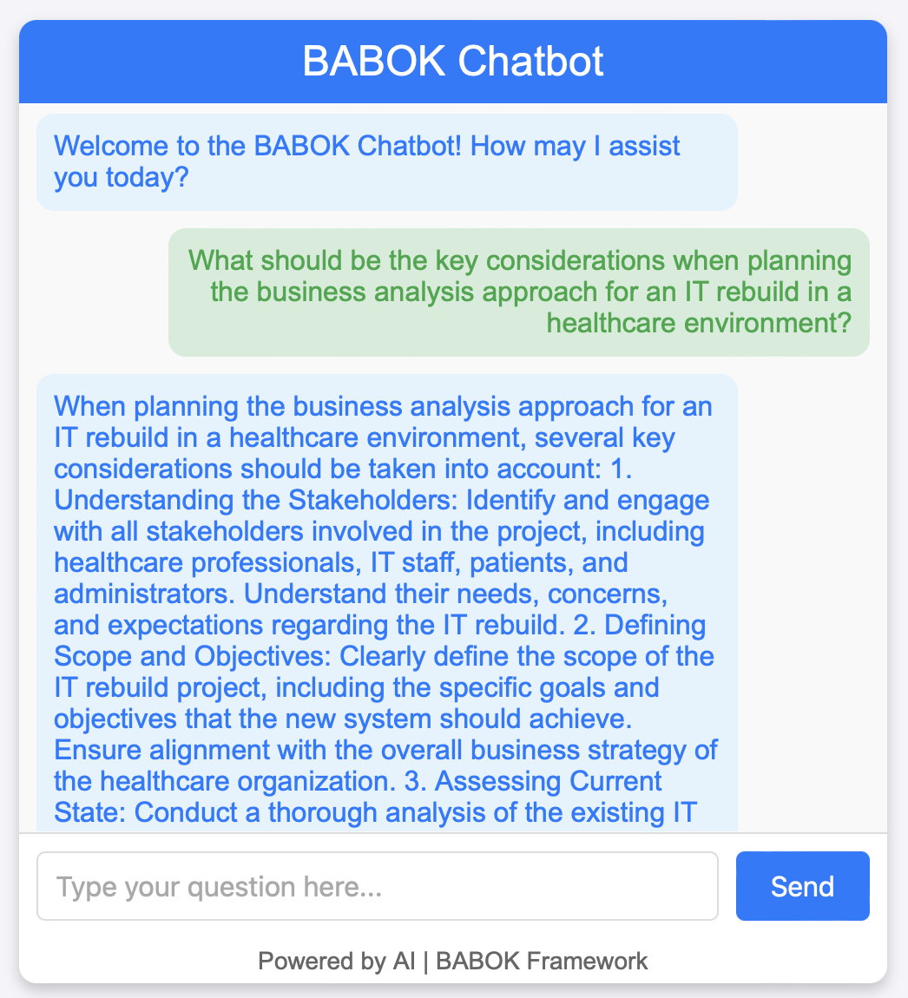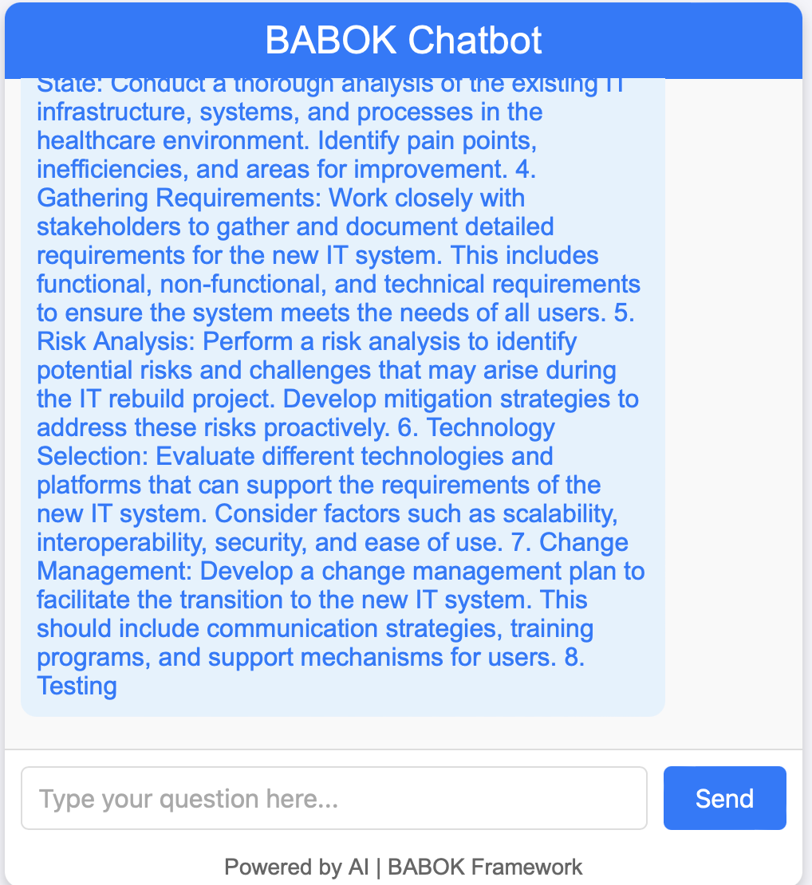

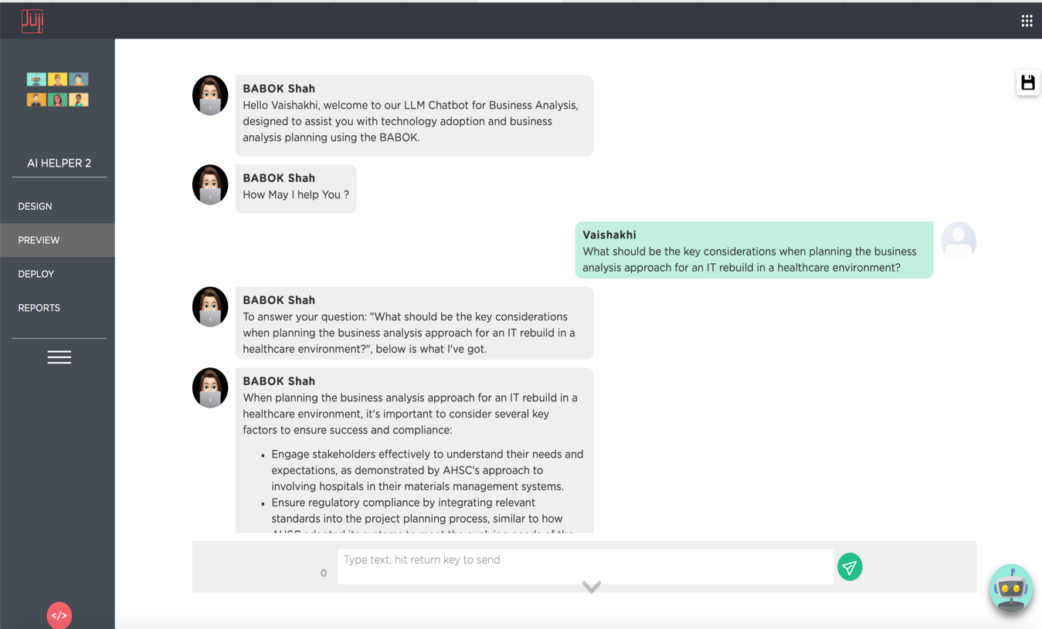

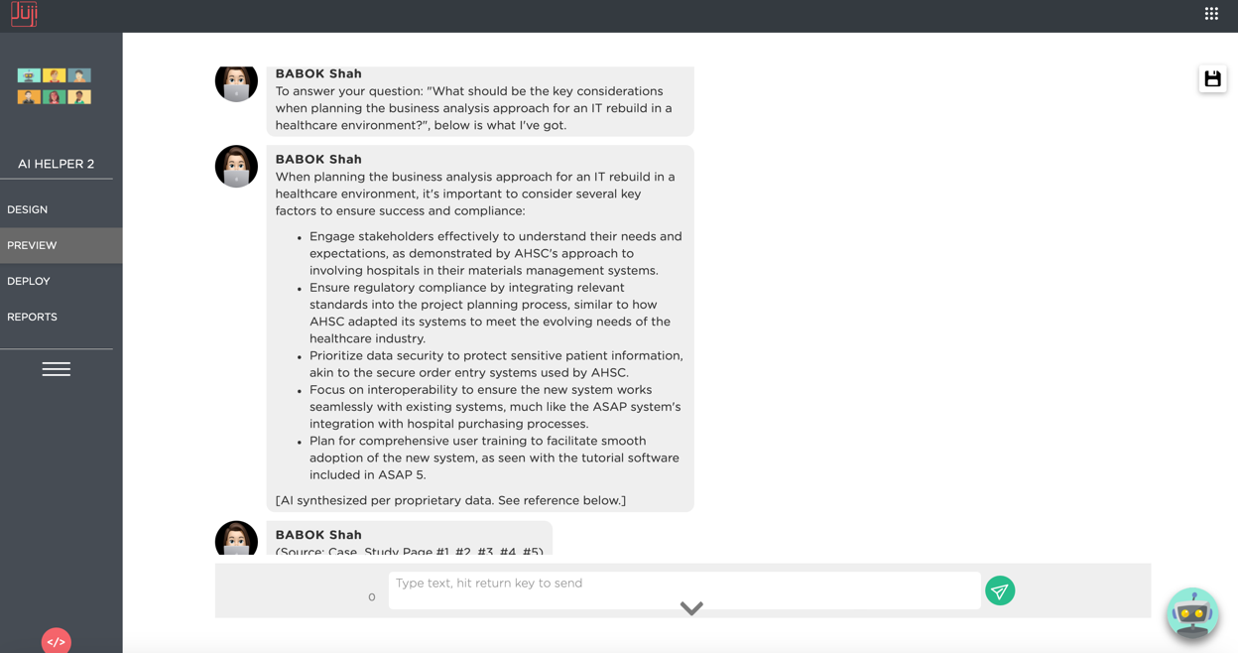

***Prompt:*** *How should the approach account for regulatory and compliance requirements relevant to the healthcare sector?*

***Response:***

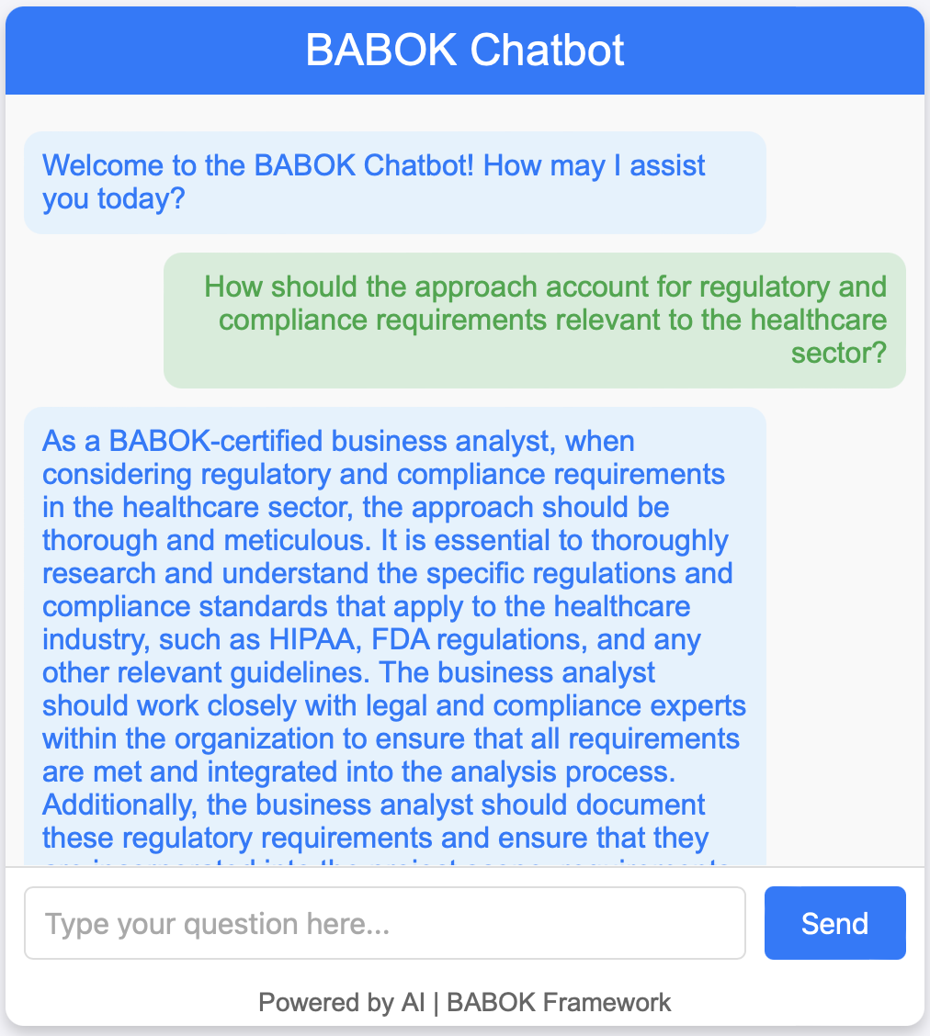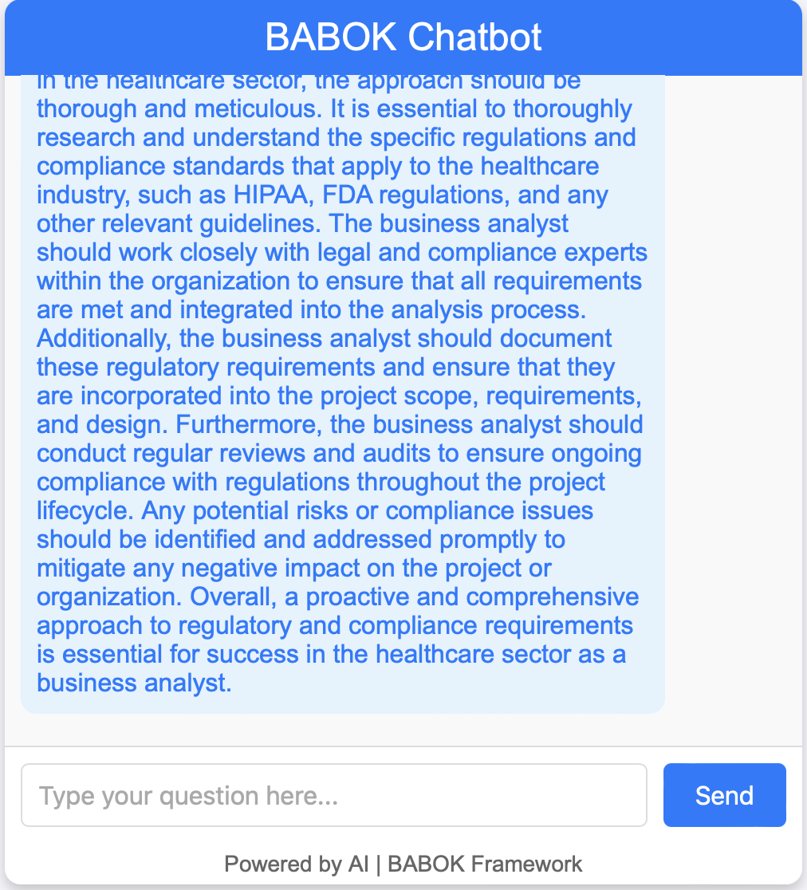

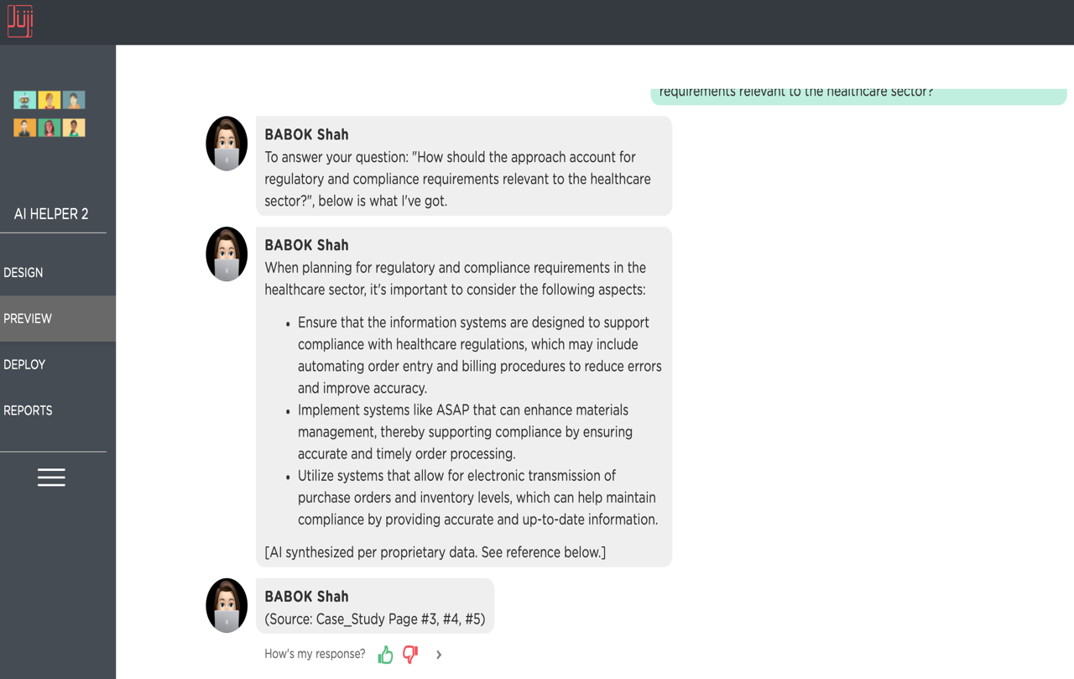

***Prompt:*** *Given that the ASAP system has several versions, how should we prioritize features or functionalities for the rebuild?*

***Response:***

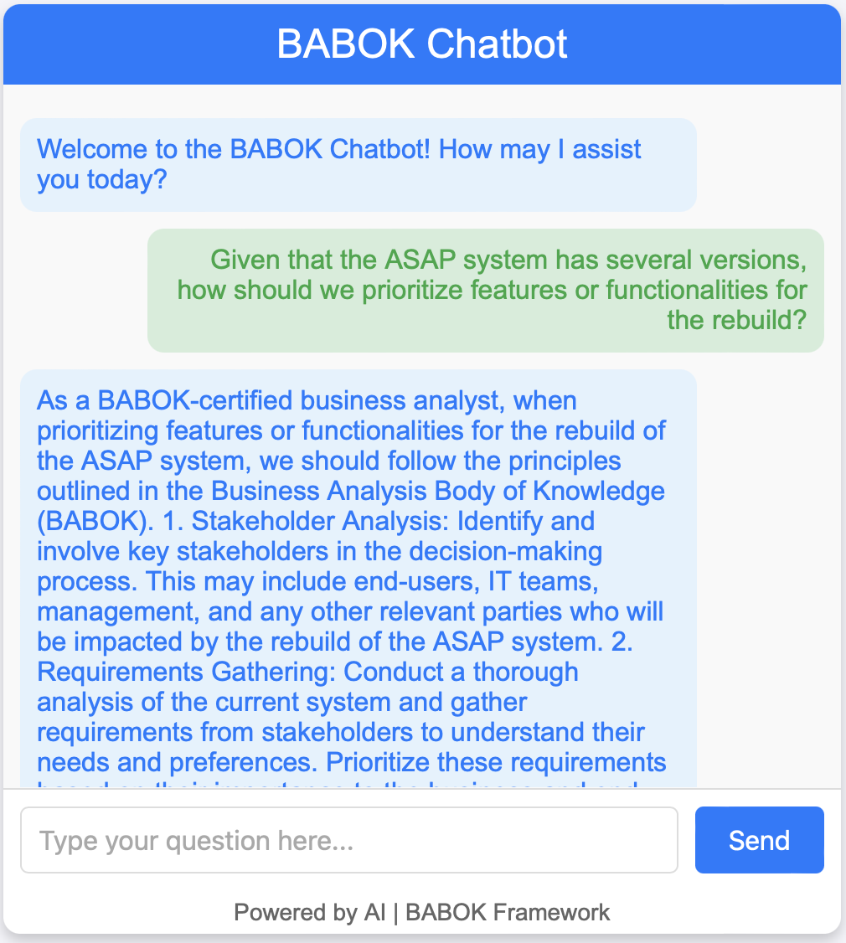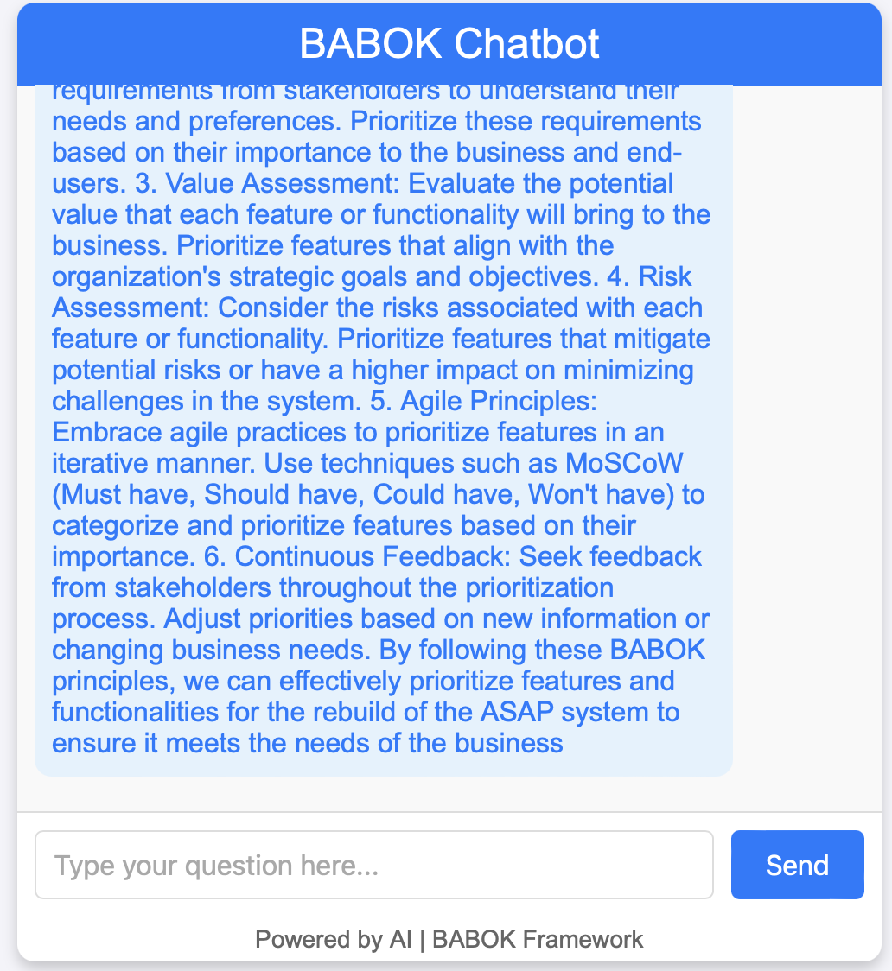

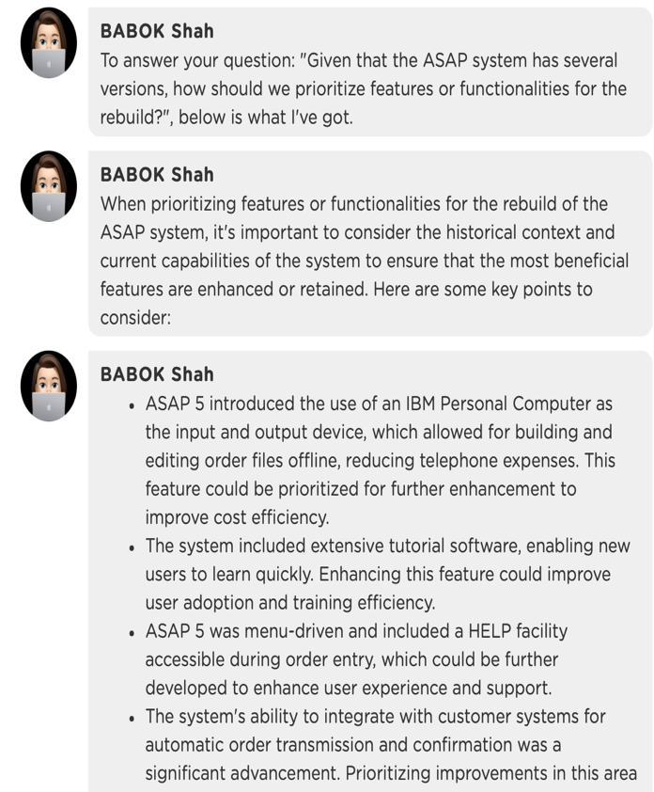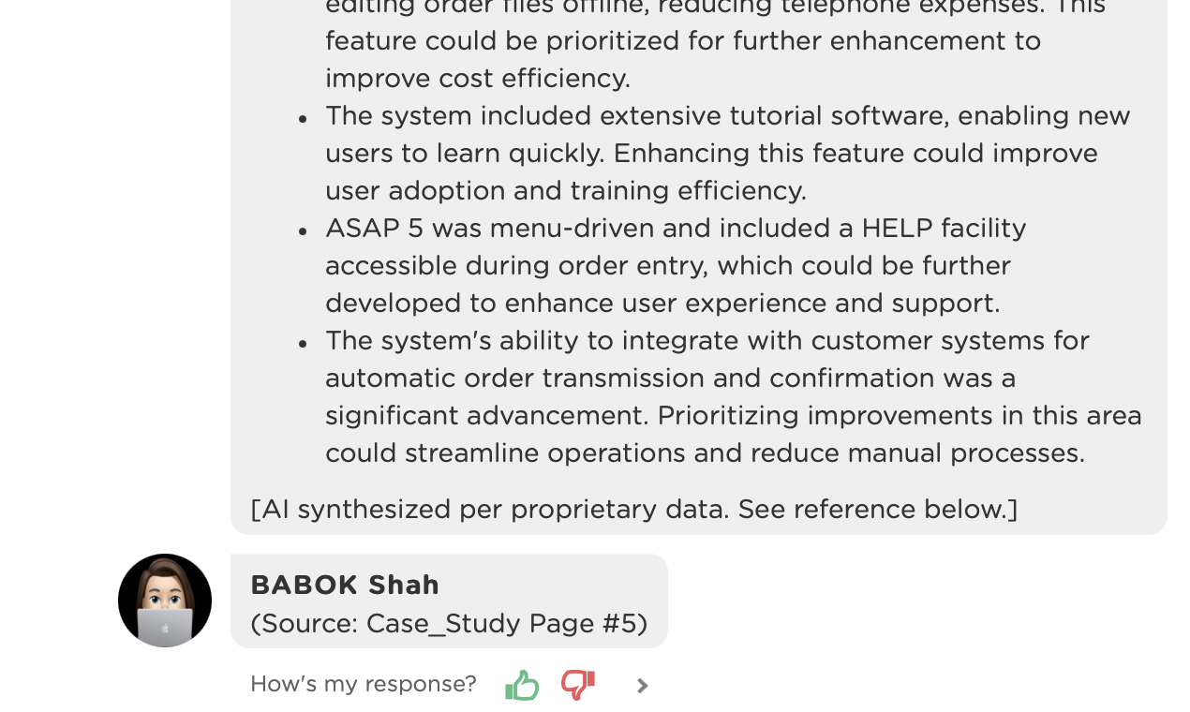

**While both responses address the questions asked and finds the solution, Response 1 for each question where, the use of Python LLM Chatbot offers a broader, more generalized approach whereas Response 2 for each question where, the use of Juji Studio Chatbot appears more specific to the case. Let’s see another example below with different objective and purpose.**

* **Identify Business Analysis Performance Improvements**

**Objective:** Assess if the chatbot can help identify and measure the effectiveness of business analysis activities.

***Prompt:*** What metrics should we establish to measure the success of the business analysis approach for the ASAP system rebuild?

***Response:***

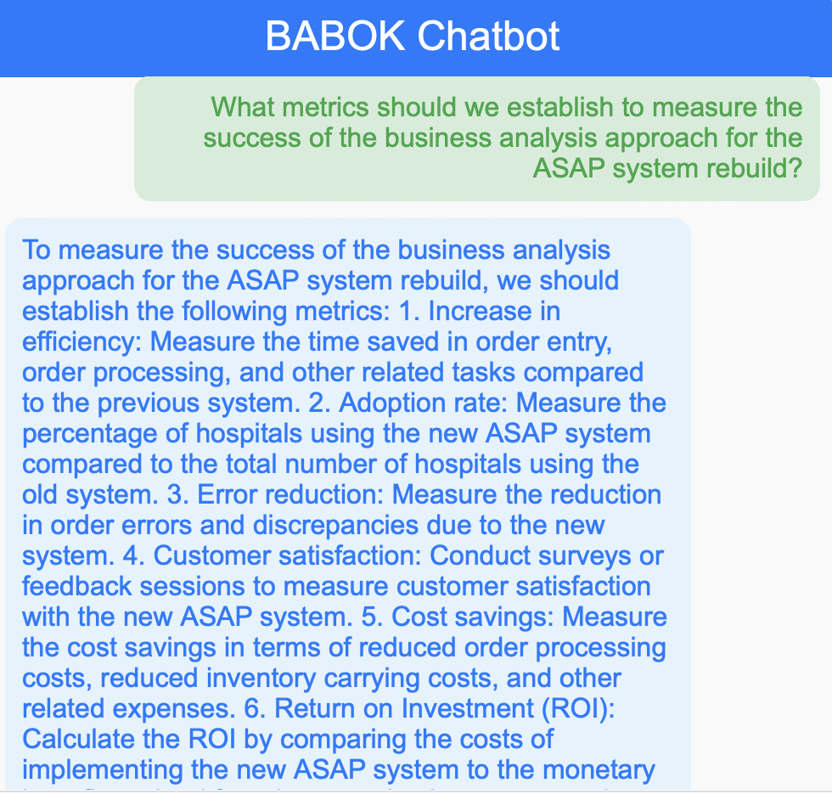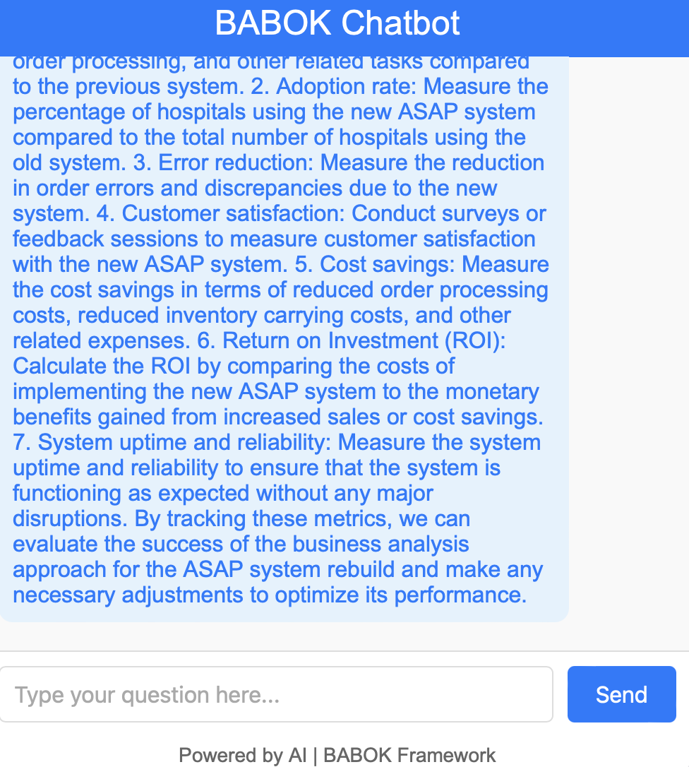

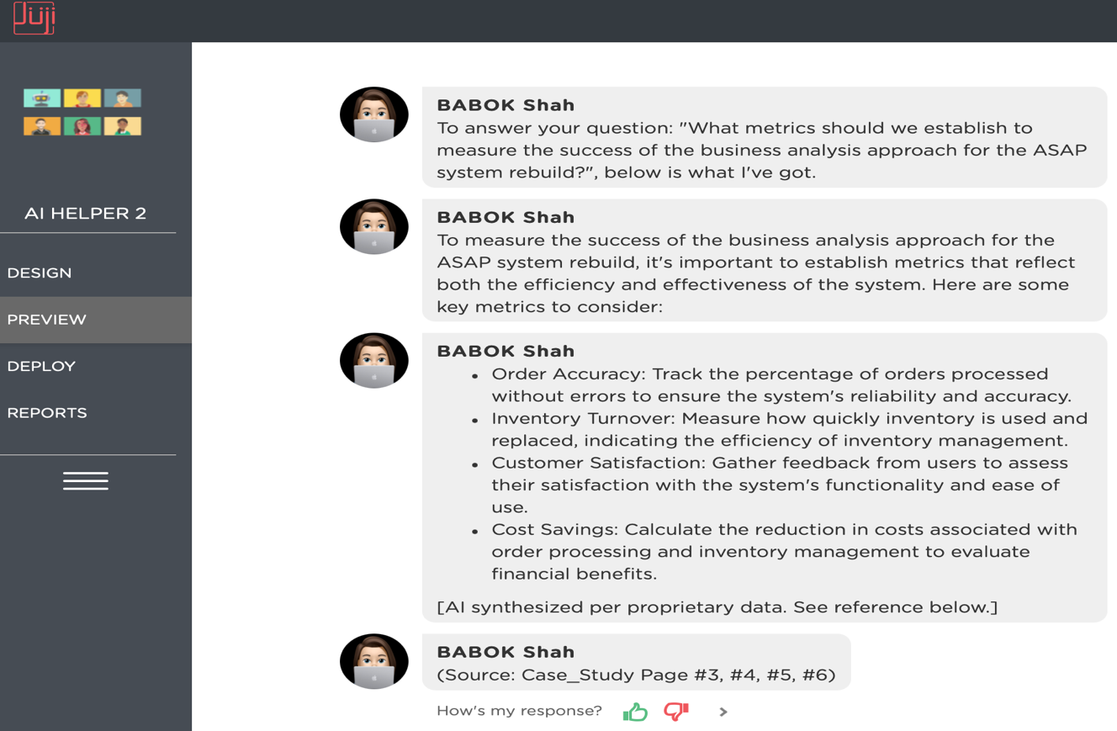

***Prompt:*** How can we ensure continuous improvement in our business analysis practices throughout the project lifecycle?

***Response:***

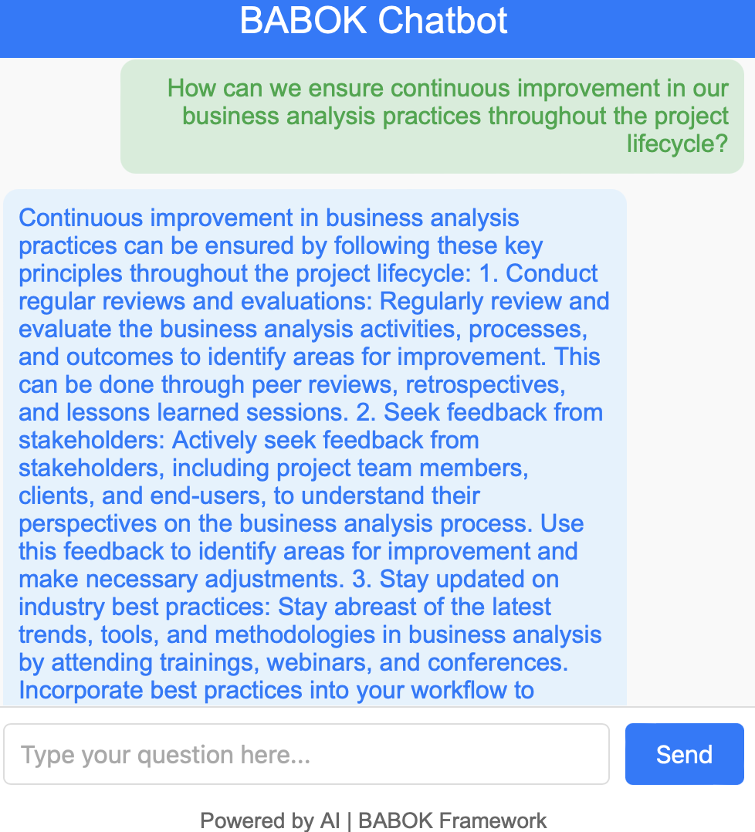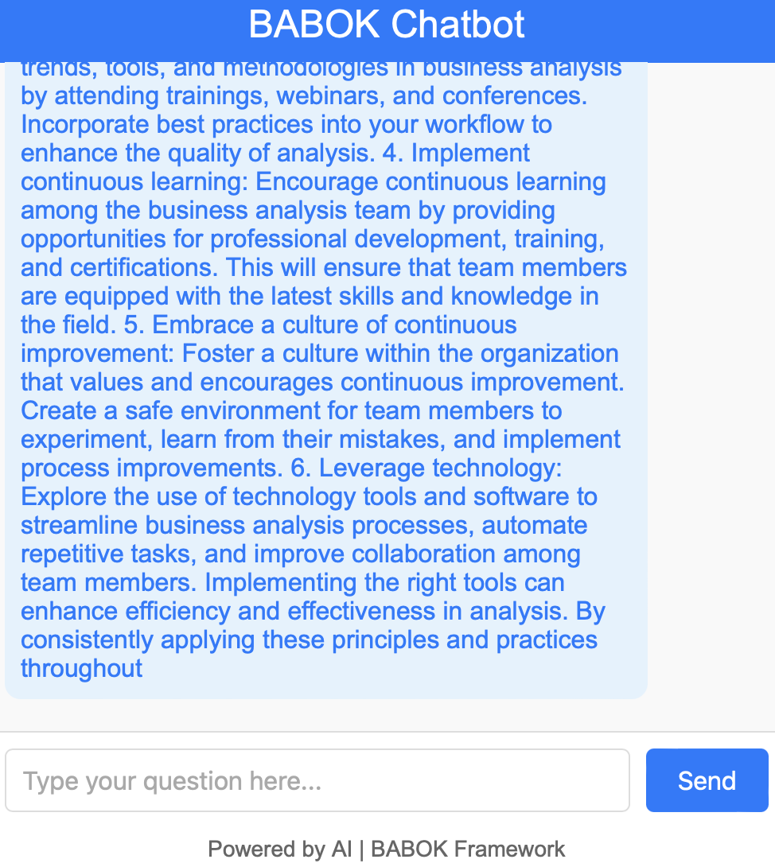

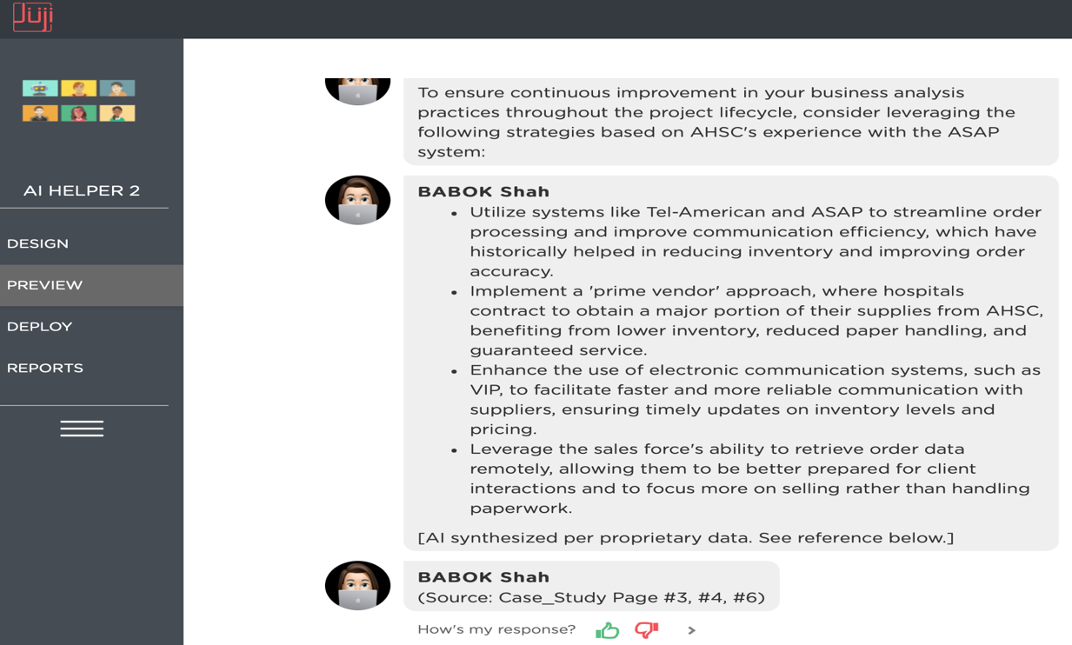

***Prompt:*** What performance improvements should be targeted to better align the project outcomes with AHSC’s business objectives?

***Response:***

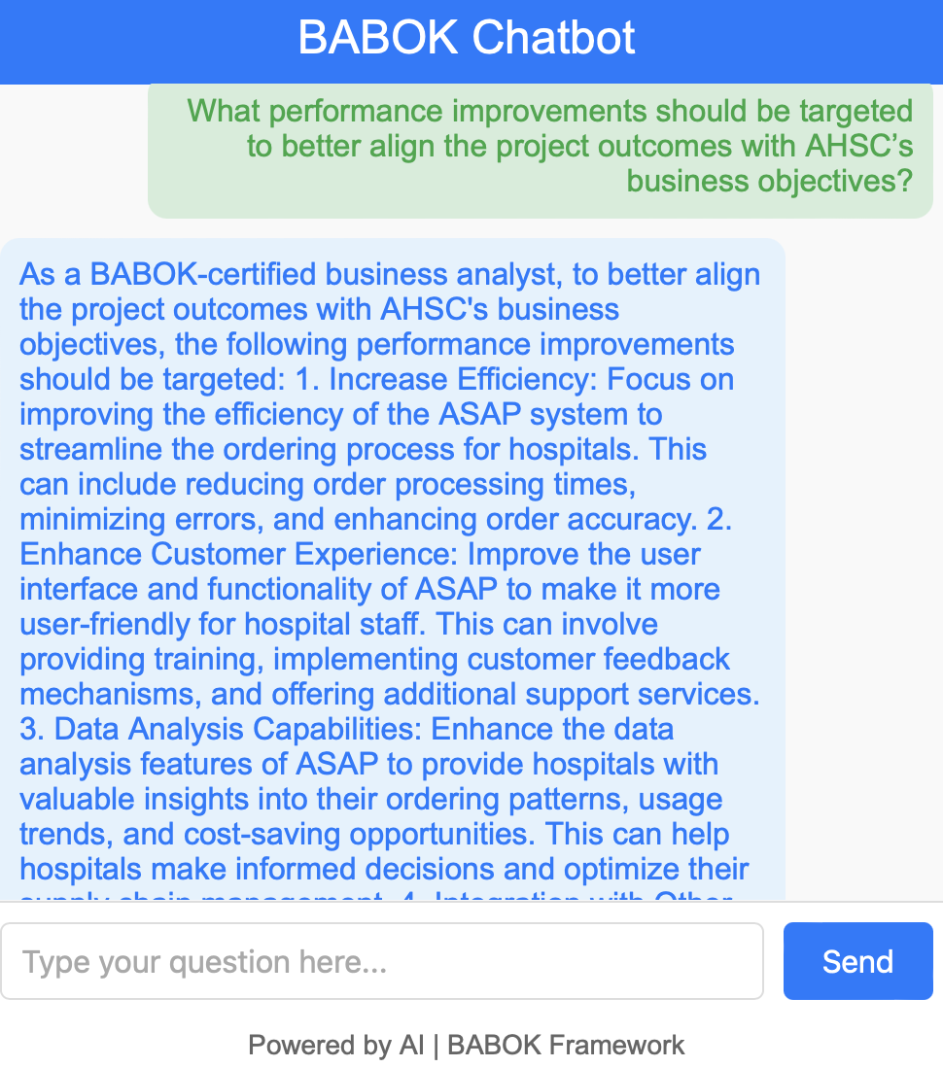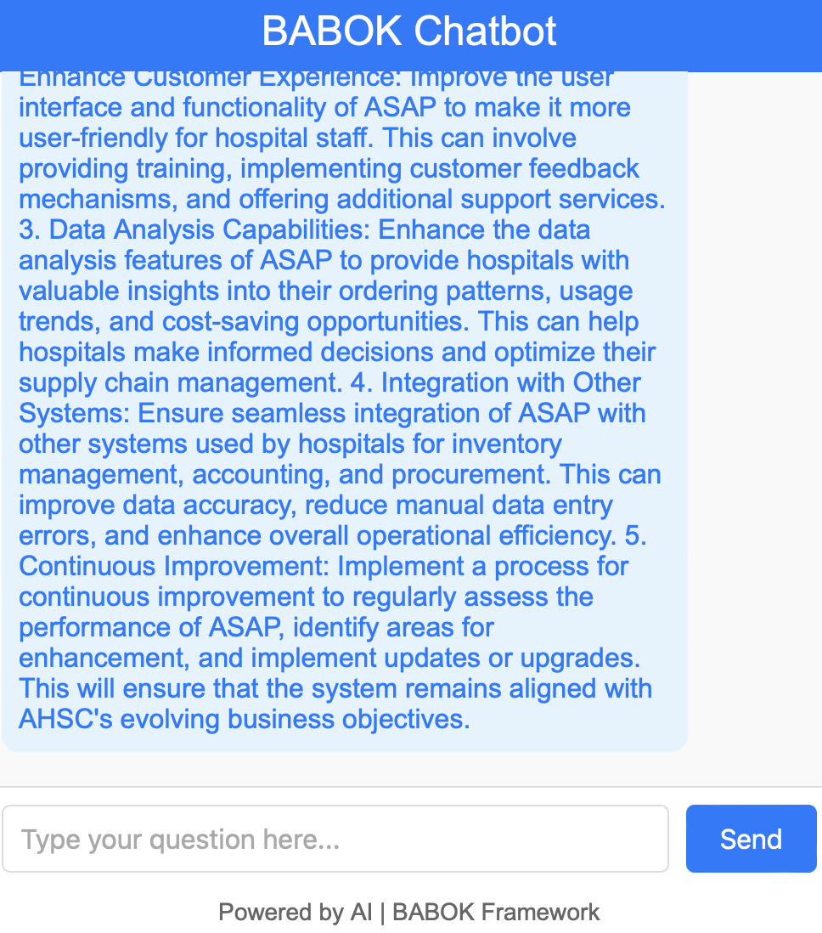

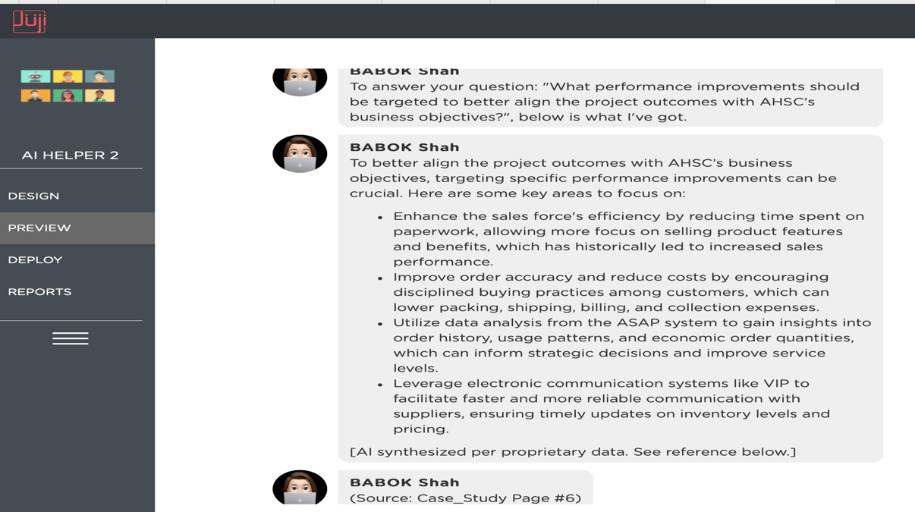

## Repository of Data Sets and Code

The data sets used for this project, along with the full code for the tool, are hosted on GitHub. You can access them at the following link: [GitHubLink](https://github.com/VaishakhiShah/Python-LLM-Chatbot)

The codebase includes the scripts for extracting data from the case study PDF, loading BABOK principles from JSON files, and running the chatbot. All relevant files for setting up the Flask app, as well as example queries and responses, are available in the repository.

## Summary of Results

In conclusion, we found that the developed tool was effective in combining business analysis principles with case study data to provide accurate, insightful responses. The tool demonstrated how artificial intelligence can assist business analysts by integrating structured knowledge (like BABOK) with real-world case data. The success of this tool is evidenced by the accuracy of its responses and the smooth integration of case study data with the BABOK framework.

This project showcases the potential of LLM-based chatbots for improving business analysis processes, allowing for more efficient decision-making, better stakeholder engagement, and more thorough evaluations of business solutions.

# Risk Analysis

Throughout the project, several potential risks were identified, each with corresponding strategies to mitigate their impact. These risks ranged from technical issues related to data extraction and chatbot accuracy to time management challenges, given the limited timeframe and the project's innovative nature. The following outlines each risk, the likelihood and impact assessments, mitigation strategies, and an evaluation of whether the risk occurred during the project.

One major risk was Data Quality Issues in the BABOK Text, assessed with high impact and medium likelihood. Extracting accurate and complete information from BABOK texts was crucial since any data inaccuracies could compromise the chatbot's effectiveness. To mitigate this, various PDF parsing tools, such as pdfplumber and PyPDF2, were tested to ensure consistent and accurate data extraction. Additionally, the extracted text was manually validated to catch any errors or omissions. This risk did occur initially, as certain sections of the text were misinterpreted by the tools. However, through repeated testing and careful validation, these issues were effectively managed, preventing any lasting data quality issues.

Another significant risk was Inaccurate or Incomplete Responses from the Chatbot, which had both high impact and high likelihood due to the complexity of aligning the LLM's outputs with BABOK principles. To manage this risk, the chatbot underwent regular testing with sample queries to ensure its responses accurately reflected the knowledge in BABOK. A fine-tuning process was also implemented, allowing the model to retrain on more specific queries when inaccuracies were observed. This risk did manifest during initial testing, as some responses lacked precision. However, by fine-tuning the model and providing targeted training on BABOK-specific content, these issues were gradually reduced, leading to more accurate chatbot outputs.

The Complexity of BABOK Content posed a high impact and medium likelihood risk, as understanding and accurately responding to complex, nuanced content in BABOK required advanced language processing. This risk was mitigated by prioritizing training on key topics within BABOK and incorporating detailed examples into the chatbot’s development. To further strengthen its contextual understanding, targeted training was conducted for critical business analysis questions, allowing the model to better grasp the nuances of BABOK. Although the chatbot occasionally struggled with more intricate queries, the targeted training reduced misunderstandings, making this risk manageable throughout the project.

Delayed Milestones due to Integration Issues had a medium impact and likelihood, given the multiple phases involved in data extraction and model integration. To address this risk, clear integration points were established with deadlines for each phase. Weekly team check-ins were used to monitor progress and quickly address potential bottlenecks. This proactive approach ensured smooth integration, and delays were minimal, demonstrating the effectiveness of regular monitoring in keeping the project on track.

Technical Bugs and Errors in Implementation were also assessed with medium impact and likelihood, as unexpected technical issues can occur in any AI-based project. The project employed agile development practices, conducting frequent testing and debugging sessions to catch and resolve issues early. Additionally, a contingency plan allowed for extra testing time if needed. Although minor bugs surfaced during development, they were resolved without major setbacks, underscoring the value of frequent testing in minimizing technical disruptions.

Beyond technical risks, the time constraint, and the learning curve of implementing a chatbot for the first time introduced unique challenges. While the limited timeframe was unavoidable, detailed planning and strict adherence to the project schedule helped prevent time-related issues. The learning curve was managed through proactive research and consulting resources on LLM integration and chatbot development. These efforts ensured the project progressed without severe time constraints, demonstrating effective time management and adaptive learning strategies.

In summary, while certain risks materialized—such as data quality issues and initial inaccuracies in chatbot responses—the mitigation strategies proved effective, allowing the project to overcome these obstacles. The combination of proactive planning, iterative testing, and frequent validation helped maintain the project’s momentum, resulting in a reliable and functional LLM-based chatbot that aligned with BABOK standards.

# Issues Encountered

During the project, several minor issues arose, but they were quickly addressed to ensure smooth progress and maintain high quality. Each of these issues, although minor, required immediate attention to prevent any delays or impact on the project’s outcomes. The issues largely aligned with anticipated risks and, in many cases, fell within the scope of the project’s risk management strategy, which facilitated effective resolution.

The first issue encountered was data extraction inaccuracies from the BABOK text. During initial extraction, some sections of the text were misinterpreted due to limitations in the PDF parsing tools. As outlined in the risk management strategy, this issue was expected to some degree, and mitigation steps included testing multiple parsing tools (pdfplumber, PyPDF2) and manually validating extracted data. This approach was effective in handling the issue quickly. After identifying and validating the discrepancies, the project team selected the most reliable tool and manually corrected the remaining errors to ensure high-quality, accurate data for chatbot training.

Another issue involved inaccuracies in chatbot responses during early testing phases. The chatbot occasionally produced responses that were either incomplete or not entirely aligned with BABOK standards. This issue was part of the initial risk assessment and was classified as a high-impact and high-likelihood risk, for which a robust mitigation plan was developed. The project team implemented a continuous testing cycle, with sample queries based on BABOK principles, to monitor the chatbot's output and identify patterns of inaccuracy. When inaccuracies occurred, the model was fine-tuned, and additional targeted training was provided on BABOK-specific topics. This process gradually improved the chatbot's response accuracy, helping the team resolve the issue without affecting the project timeline.

Complexity of context understanding within BABOK content presented another challenge. The chatbot sometimes struggled to comprehend the nuances of complex business analysis queries, which was anticipated as a moderate-likelihood risk. The mitigation strategy involved providing additional context and examples during the chatbot’s training to refine its understanding of complex topics. The project team focused on BABOK’s critical concepts and created targeted prompts to improve the chatbot’s ability to respond to specific types of queries. Through this method, the chatbot’s responses became more contextually accurate, minimizing the impact of this issue on the project’s progress.

Technical bugs and errors emerged as well, particularly during the integration of various project components, such as data extraction, the LLM model, and the user interface. Although these technical issues were initially unexpected, the project’s agile development methodology allowed the team to catch and resolve them early. Each issue was tested in isolation, and frequent debugging sessions were held to identify root causes and implement solutions. Regular, iterative testing ensured that these bugs did not accumulate or interfere with other project components, demonstrating the effectiveness of the agile approach in addressing technical challenges.

Additionally, time management was a minor challenge due to the limited timeframe and the learning curve associated with implementing an LLM-based chatbot. While the team anticipated these constraints, detailed planning and strict adherence to milestones helped maintain a steady workflow. Weekly team check-ins allowed for open discussions on progress and any emerging challenges, enabling prompt course corrections and time-efficient solutions. By actively managing time and incorporating regular feedback loops, the team was able to stay on track and complete the project within the designated schedule.

Overall, while these issues were minor, they aligned closely with anticipated risks, allowing the team to apply its mitigation strategies effectively. Each issue was addressed immediately upon identification, ensuring that the project was completed on time and maintained a high standard of quality. This proactive approach to problem-solving demonstrated the value of comprehensive risk planning, regular testing, and agile methodologies, all of which contributed to the project’s successful completion.

# Project Chronology and Critique

According to the WBS (Work Breakdown Structure), the project schedule is showed as below. The planned deliver start and finish time data are also listed for task adjustments for different phases.

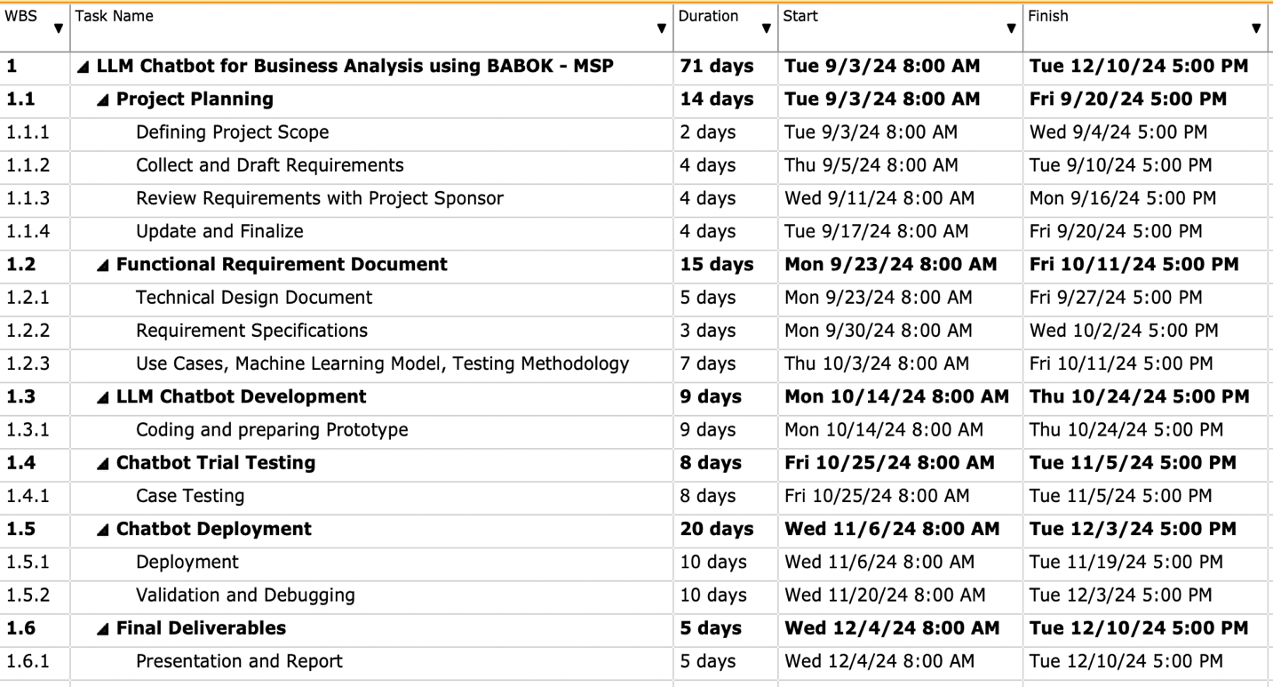

The development of the LLM-based BABOK chatbot followed a structured yet adaptive approach, progressing through distinct phases: project planning, research, design and development, testing, and refinement. This project timeline highlights both the milestones achieved and the challenges encountered, along with reflections on areas where improvements could have been made.

The project began with a comprehensive planning phase, where I defined the scope, objectives, and expected outcomes. My initial research focused on understanding both the BABOK framework in detail and the latest developments in large language model (LLM) technology, specifically the capabilities of GPT-4 for delivering context-aware responses. The research revealed the potential of LLMs to support structured knowledge-based applications, confirming the feasibility of integrating BABOK within a chatbot model. However, in retrospect, dedicating additional time to a competitive analysis of similar AI tools could have provided further insight into user interface design, potentially improving the chatbot's usability from the outset.

The design phase involved translating BABOK concepts into chatbot prompts and structuring the workflow for efficient query-response generation. During development, I used Python and leveraged the GPT-4 API to enable natural language processing (NLP) capabilities. Building the backend was a complex process, as it required ensuring that the chatbot could deliver BABOK-compliant answers tailored to business analysis scenarios. One challenge here was refining the prompts to maximize relevance and reduce ambiguity in the responses. Iterative testing was essential to improve response accuracy, but in hindsight, earlier involvement of end-users or beta testers could have provided valuable feedback on the prototype's practical functionality, allowing for more refined prompts before full-scale testing.

Testing was carried out using a combination of predefined and dynamic case studies to evaluate the chatbot’s accuracy, relevance, and efficiency. I conducted several rounds of testing to ensure that the chatbot responses aligned with BABOK standards, analyzing metrics such as response time and contextual relevance. This phase revealed areas where the chatbot could benefit from additional fine-tuning, particularly in handling more nuanced questions that require an understanding of broader project contexts. While this iterative testing improved the overall quality, scheduling additional time for continuous testing throughout development would have allowed for a smoother refinement process and might have accelerated the identification of minor flaws.

Looking back on the project, one area for improvement would have been to integrate user feedback earlier in the development process. I underestimated the value of incorporating perspectives from target users—business analysts—during the design and testing phases. Their insights would have highlighted usability needs and practical challenges that only become apparent through regular use, helping me to address these aspects before the final stages.

Additionally, enhancing the project’s documentation process would have made the development phases more efficient and traceable. While I maintained thorough records, a more structured documentation framework with regularly updated logs would have aided in identifying recurring issues and capturing successful modifications in real time. In future projects, I would prioritize ongoing documentation as a key component, allowing for better tracking of development decisions and a smoother handoff if additional team members join later stages.

Overall, the project provided valuable lessons on the importance of user-centered design, continuous testing, and documentation in creating a robust AI-driven tool. Each stage contributed to the successful creation of a chatbot that aligns with BABOK standards and serves as a proof of concept for AI-assisted business analysis, laying the groundwork for future improvements and scalability.

# Lessons Learned

The whole project was able deliver as planed with expected quality and in time and this could not have been done without contribution and help from the mentors and sponsor. During the project implementation, I have learned the business benefit of the project: Increased Efficiency in Business Analysis, Improved Decision-Making, Human Error Reduction, Timesaving in Training and Learning, Proof of Concept for AI-Driven Business Solutions, Standardization of Business Analysis Practices. The successful completion of this project provided me with a range of insights and skills that extended beyond my technical understanding of AI and business analysis. One of the most valuable lessons was learning how to effectively integrate AI capabilities, like those of an LLM, into a structured framework such as the Business Analysis Body of Knowledge (BABOK). The process involved translating BABOK concepts into machine-understandable prompts, which taught me how to break down complex information into structured, actionable components. Additionally, I gained in-depth knowledge of the intricacies of using GPT-4, Juji Studio, Python including prompt engineering, model optimization, and ensuring responses remain contextually relevant. The practical experience of working with LLMs for such a specialized application was an invaluable part of my learning.

Another significant lesson was in project management, particularly in timeline planning, task allocation, and maintaining momentum throughout each project phase. Having clear milestones and objectives helped the project progress smoothly. I also improved my skills in risk management, learning to anticipate and mitigate risks as they arose. For example, I realized early in the development phase that certain technical challenges, such as ensuring the accuracy and contextual relevance of the chatbot’s responses, might cause delays if not addressed proactively. By implementing an iterative testing approach and regularly monitoring the accuracy of responses, I could identify and resolve potential issues early, preventing them from affecting later stages. This experience has taught me that proactive risk assessment and continuous monitoring are essential for keeping complex projects on track.

Lastly, the project gave me a new appreciation for stakeholder management and the importance of continuous communication. My sponsor, Dr. Andres Fortino, and my advisor Professor Dan Stone played a critical role in shaping the project’s direction, providing feedback on functionality, usability, and alignment with industry standards. I learned to seek out feedback regularly and make iterative adjustments based on input, which helped ensure that the final deliverable met both the sponsor’s and end users’ expectations. Building these feedback loops taught me the importance of active stakeholder engagement and how to navigate the balance between project objectives and stakeholder expectations.

Overall, the applied project allowed me to deepen my technical expertise, enhance my project management abilities, and strengthen my collaboration and communication skills. Each of these lessons has equipped me with practical knowledge and competencies that I can apply to future projects, ensuring continuous growth and adaptability in my professional career.

# Conclusion and Summary

The project “Creating an LLM Chatbot for Business Analysis Using the BABOK” focuses on leveraging the BABOK (Business Analysis Body of Knowledge) to create a chatbot that will assist business analysts in efficiently accessing best practices and guidelines for complex business analysis scenarios, particularly in technology adoption and project planning. The objective is to design, develop, and deploy a proof of concept (POC) chatbot that can provide relevant, real-time advice based on BABOK principles, aiming to improve decision-making efficiency, reduce errors, and decrease training time for business analysts. The project is designed to be completed within the constraints of a university fall semester and involves milestones such as requirement specification, technical design, chatbot development, trial testing, and final validation. The key deliverables include the functional chatbot, testing results, and a final report documenting the process and outcomes.

This project represents an innovative approach to integrating AI with business analysis practices by creating a chatbot that can dynamically respond to business analysis queries based on the BABOK. The chatbot's ability to quickly provide relevant information and reduce the reliance on manual reference will likely enhance business analysts' efficiency, improve decision-making, and lower the time spent on training and learning. However, as this is a proof of concept, the project’s current scope is limited, and future work will involve scaling and enhancing the chatbot's capabilities. The success of this project will demonstrate the potential of AI to revolutionize traditional business analysis processes and pave the way for more robust, AI-driven tools in the field. The full potential of this tool will be realized when fully developed and deployed in a real-world scenario, addressing the broader needs of business analysts in various industries. Additionally, all relevant resources, including the tool code, datasets, and analysis spreadsheets, is published on the GitHub repository and a dedicated link for project is also made available.

# Limitations, Recommendations and Scope for Future Work

While this project successfully delivered an LLM-based chatbot incorporating BABOK principles, certain limitations remain, and areas for future improvement have been identified. Expanding the scope in subsequent projects could enhance the tool’s accuracy, scalability, and adaptability in business analysis applications.

A key limitation was the selective training on BABOK content, focusing on core sections due to time and data constraints. As a result, the chatbot may lack comprehensive knowledge across all BABOK topics. Future projects could broaden the dataset to cover more areas, improving the chatbot's capacity to answer a wider range of business analysis queries. Additionally, access to real-world case data was limited, restricting the chatbot’s exposure to diverse, authentic scenarios. Partnering with industry sources to incorporate anonymized case data would allow for more effective training and testing, enabling better real-world applicability.

Model fine-tuning is another area for enhancement. The chatbot was optimized for general queries, but further adjustments are needed to improve response accuracy on complex questions. Future projects could implement regular updates and retraining cycles, keeping the model aligned with evolving information and user needs. Technical constraints related to processing speed also limited real-time responsiveness. Future versions could explore cloud-based deployment and backend optimizations to support scalability and faster responses, particularly for high-demand settings.

Based on this project’s experience, future work should also consider Juji Studio or similar low-code platforms to simplify chatbot development, as they allow faster prototyping and deployment with limited coding. Juji could be explored as a primary development tool, especially for educational projects or limited-resource settings.

Finally, future versions could incorporate user feedback mechanisms to continually refine the chatbot. Collecting and analyzing user feedback would help align responses with user expectations and industry standards. Further enhancements could include advanced decision-making support, such as scenario analysis and decision trees, to provide more robust business analysis guidance.

In summary, while this project established a solid foundation, addressing these limitations and extending the scope could result in a more versatile, comprehensive tool, advancing the NYU MASY program’s mission to equip students with innovative solutions in business analysis.

# Literature Survey

In today's rapidly evolving business environment, efficient access to structured industry knowledge is crucial for business analysts. The project aims to design a chatbot utilizing the BABOK framework to support business analysts with quick access to industry standards and best practices, particularly in dynamic project planning scenarios​. The challenge lies in the time-consuming nature of traditional methods for consulting industry knowledge bases. Business analysts need a solution that offers efficient, contextually relevant guidance on complex case analysis and technology adoption​.

Chatbots are AI-driven conversational interfaces that facilitate interactions by automating responses. They have become instrumental in customer service, data-driven insights, and process automation, enhancing decision-making efficiency (Chuma & De Oliveira, 2023). The Business Analysis Body of Knowledge (BABOK), from the International Institute of Business Analysis, is an essential framework that provides standards for business analysis processes. BABOK’s principles align well with LLM-driven models to offer structured insights tailored for project cases and decision-making (Ngo Tran et al., 2024). Large Language Models are advanced AI models that leverage vast datasets to generate human-like text, perform complex linguistic tasks, and support decision-making processes (Dam et al., 2024). LLMs like GPT-4, with extensive contextual understanding, make ideal tools for knowledge synthesis and can respond to structured prompts for use in decision-making environments.

The motivation for developing an LLM-based chatbot that integrates the BABOK framework is rooted in the need for rapid, contextually relevant, and efficient access to business analysis best practices. Traditional methods of consulting structured resources like the BABOK are often time-consuming, requiring analysts to sift through volumes of information to find relevant insights. Moreover, as business analysis becomes increasingly complex and globalized, the need for real-time, reliable guidance has grown significantly (Chuma & De Oliveira, 2023). Studies highlight that AI and LLM-driven tools can increase productivity, enhance decision-making, and support users in performing complex tasks, making them invaluable in fields that rely heavily on structured knowledge and timely decision-making (Dam et al., 2024).

Without the LLM chatbot, business analysts rely on manually consulting the BABOK or other industry resources, which can be both time-intensive and inefficient in fast-paced project environments. Traditional business analysis tasks involve manual document reviews, expert consultations, and frequent meetings to consolidate best practices from the BABOK framework​. Such approaches, while effective for deep-dive analyses, are not always efficient for tasks that require quick, context-aware decisions, especially in dynamic business settings where rapid adaptability is crucial (Ferreira et al., 2021).

The LLM chatbot provides unique value by delivering immediate, tailored insights from the BABOK framework, reducing time spent on manual document review and improving decision relevance. Similar AI-driven tools have shown substantial benefits in various domains by providing users with timely access to structured knowledge. For instance, the use of LLM-based chatbots in customer service has led to improved response times and customer satisfaction (Goswami & Gupta, 2024). Additionally, research supports that AI tools embedded with domain-specific knowledge enable better decision-making by delivering more relevant information aligned with industry best practices (Ferreira et al., 2021).

In designing this chatbot, a key choice was to use an LLM model integrated with BABOK principles to enable contextual decision-making and streamlined responses. This approach was selected over simpler rule-based systems due to the LLM’s ability to process natural language inputs and provide nuanced responses. Rule-based systems, while useful for static information, fall short in dynamic environments where understanding context is crucial (Dam et al., 2024). The choice of an LLM, such as GPT-4, allows for higher adaptability and relevance, aligning well with the needs of business analysts seeking on-demand, contextually appropriate advice.

Python was chosen as the primary development language due to its compatibility with machine learning libraries and ease of integration with LLM models. Python is widely regarded for its rich ecosystem of libraries that are essential for implementing LLM-based solutions. The language’s readability and extensive documentation further make it suitable for rapid prototyping and testing in AI-based projects (Kumar et al., 2023). Python’s popularity in data science and machine learning also provides a wealth of resources and community support, enabling efficient troubleshooting and continuous improvement in complex projects (Goswami & Gupta, 2024). Another research by Chen et al. (2022) showcased the easy and simple implementation using the Juji Studio to implement and prepare the Chatbot when there is time constraint.

The core algorithm of this tool is based on the transformer architecture underlying LLMs. This architecture is particularly suited to tasks involving natural language understanding and generation, as it can capture long-range dependencies within the text, making it ideal for applications that require nuanced responses. Transformers have proven successful in tasks that require language comprehension, making them an appropriate choice for generating context-aware insights from BABOK’s structured information (Ngo Tran et al., 2024). The algorithm's ability to handle complex input queries and provide refined, detailed outputs supports its application in business analysis.

Experiments with LLM-based AI tools in other fields provide a foundation for this project, demonstrating the potential for enhanced decision-making and operational efficiency. Research by Kumar et al. (2023) shows that AI-driven chatbots can improve task efficiency by up to 40%, especially in scenarios requiring detailed information retrieval. Additionally, the trials planned for this chatbot, which include real-world business cases, are intended to validate its effectiveness compared to traditional methods​ (Ferreira et al., 2021).

With AI-based solutions, adoption risk must be managed by considering potential biases, data privacy issues, and operational impacts. Developing an LLM chatbot introduces risks related to data accuracy, user trust, and adaptability across different scenarios (Kumar et al., 2023). Risk management strategies, including controlled testing, feedback loops, and security measures, are essential for effective deployment in a professional setting.

The primary data for this chatbot consists of structured information from the BABOK framework, supplemented by case studies and predefined queries to help train and refine the chatbot’s responses. The data from case studies provides practical scenarios, which are essential for testing the chatbot’s context awareness and relevance in real-time. Furthermore, the integration with BABOK serves as a foundational knowledge base, ensuring that all responses adhere to established standards and best practices, enhancing the reliability and credibility of the tool's outputs (Ngo Tran et al., 2024).

In conclusion, the literature reviewed demonstrates that using AI-driven LLM chatbots integrated with structured industry knowledge, such as the BABOK, holds considerable promise for advancing business analysis practices. Research shows that AI-based chatbots can significantly enhance task efficiency and decision-making quality, making them well-suited to meet the growing demand for real-time, contextually relevant insights in fast-paced business environments (Chuma & De Oliveira, 2023; Ferreira et al., 2021). Studies on generative AI and LLMs highlight their capacity for deep linguistic comprehension and their transformative impact across various fields, from customer service to complex decision support (Dam et al., 2024; Goswami & Gupta, 2024). These insights have underscored the need for a similar solution in business analysis, where traditional methods are often time-intensive and lack contextual adaptability. This alignment of LLM potential with industry challenges has motivated the development of an LLM chatbot for business analysis, aiming to bridge the gap between static knowledge bases and dynamic problem-solving requirements.

The reviewed literature reveals that while AI and LLM-driven tools have been successfully applied in domains requiring structured decision-making, there remains limited research on their integration with business analysis frameworks like BABOK. Existing studies primarily explore general AI chatbot capabilities or specific applications in customer-facing environments rather than in-depth business analysis scenarios (Ngo Tran et al., 2024). The gap in literature around specialized knowledge based LLM applications suggests that while the foundational capabilities of LLMs are well-understood, their deployment in niche domains, such as guided business analysis, is relatively unexplored. This lack of direct research strengthens the rationale for this project, as it seeks to extend LLM applications into structured, domain-specific areas of business analysis.

Synthesizing insights from these studies supports the approach taken in this project, emphasizing that AI can improve not only the accessibility of domain knowledge but also its practical application in time-sensitive situations. Through this review, it became clear that the LLM chatbot must be designed with the ability to deliver context-specific, actionable insights aligned with BABOK standards, distinguishing it from generic AI chatbots that lack this targeted functionality. Considering this literature, the project solution is positioned to offer business analysts a streamlined, adaptive tool that not only enhances efficiency but also reinforces best practices in decision-making.

# References

Chen, Y., Jensen, S., Albert, L. J., Gupta, S., & Lee, T. (2023). Artificial intelligence (AI) student assistants in the classroom: Designing chatbots to support student success. *Information Systems Frontiers*, *25*(1), 161-182. <https://doi.org/10.1007/s10796-022-10291-4>

Chuma, E. L., & De Oliveira, G. G. (2023). Generative AI for business decision-making: A case of ChatGPT. *Management Science and Business Decisions*, *3*(1), 5-11. <https://doi.org/10.52812/msbd.63>

Dam, S. K., Hong, C. S., Qiao, Y., & Zhang, C. (2024). A complete survey on llm-based ai chatbots. *arXiv preprint arXiv:2406.16937*. <https://doi.org/10.48550/arXiv.2406.16937>

Ferreira, D., Portela, F., & Santos, M. F. (2021). A step towards the use of chatbots to support the enterprise decision-making processes. In *Trends and Applications in Information Systems and Technologies: Volume 4 9* (pp. 308-317). Springer International Publishing. <https://doi.org/10.1007/978-3-030-72654-6_30>

Goswami, I., & Gupta, D. (2024). Building and AI Chatbot using LLM.

Kumar, V., Srivastava, P., Dwivedi, A., Budhiraja, I., Ghosh, D., Goyal, V., & Arora, R. (2023, December). Large-Language-Models (LLM)-Based AI Chatbots: Architecture, In-Depth Analysis and Their Performance Evaluation. In *International Conference on Recent Trends in Image Processing and Pattern Recognition* (pp. 237-249). Cham: Springer Nature Switzerland. <https://doi.org/10.1007/978-3-031-53085-2_20>

Ngo Tran, G. T., Le Dinh, T., & Pham-Nguyen, C. (2024, August). BABot: A Framework for the LLM-Based Chatbot Supporting Business Analytics in e-Commerce. In *International Conference on Computational Collective Intelligence* (pp. 185-198). Cham: Springer Nature Switzerland. <https://doi.org/10.1007/978-3-031-70816-9_15>

# Appendix A - Project Acceptance Document

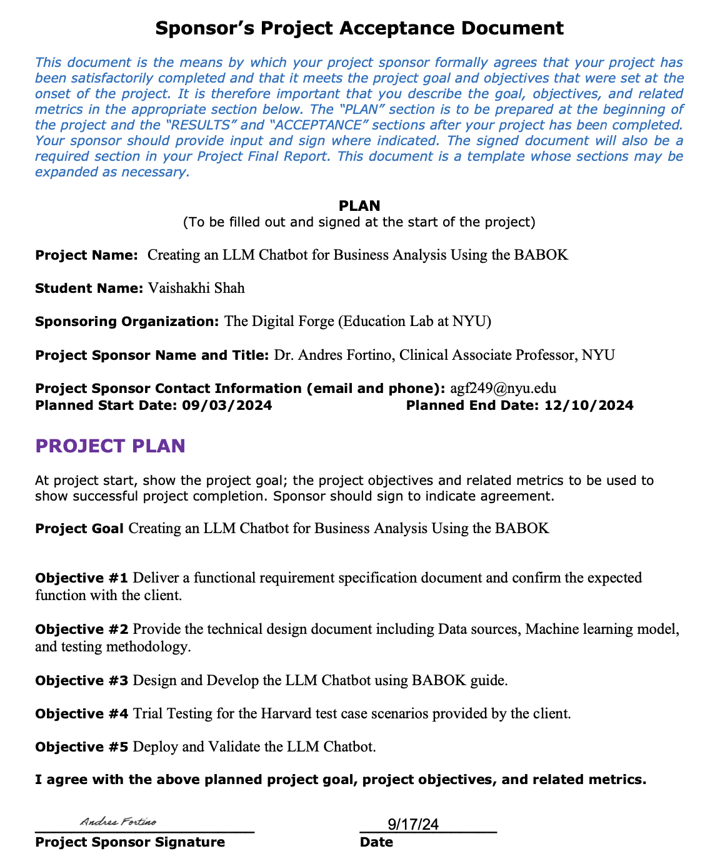

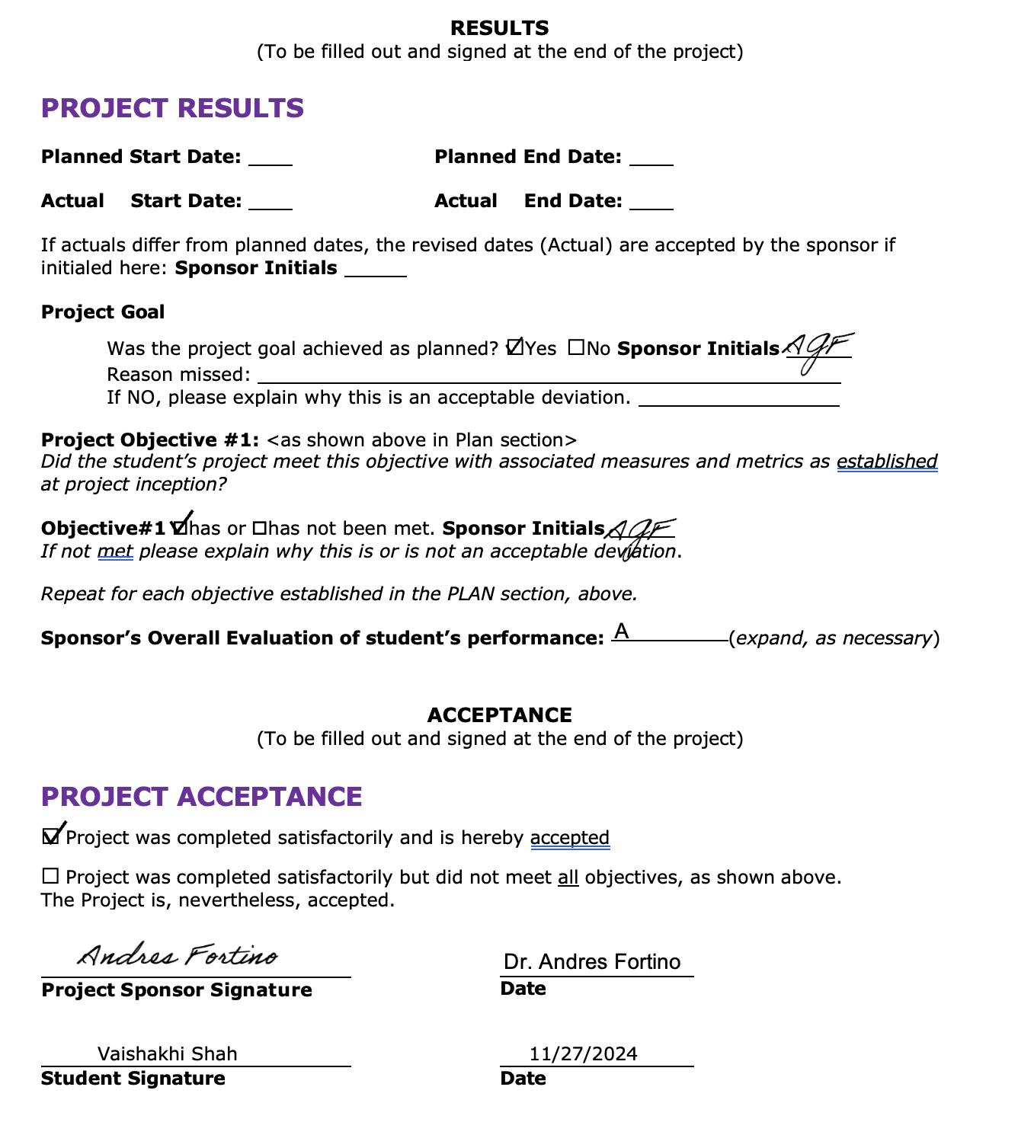

# Appendix B - Project Sponsor Agreement

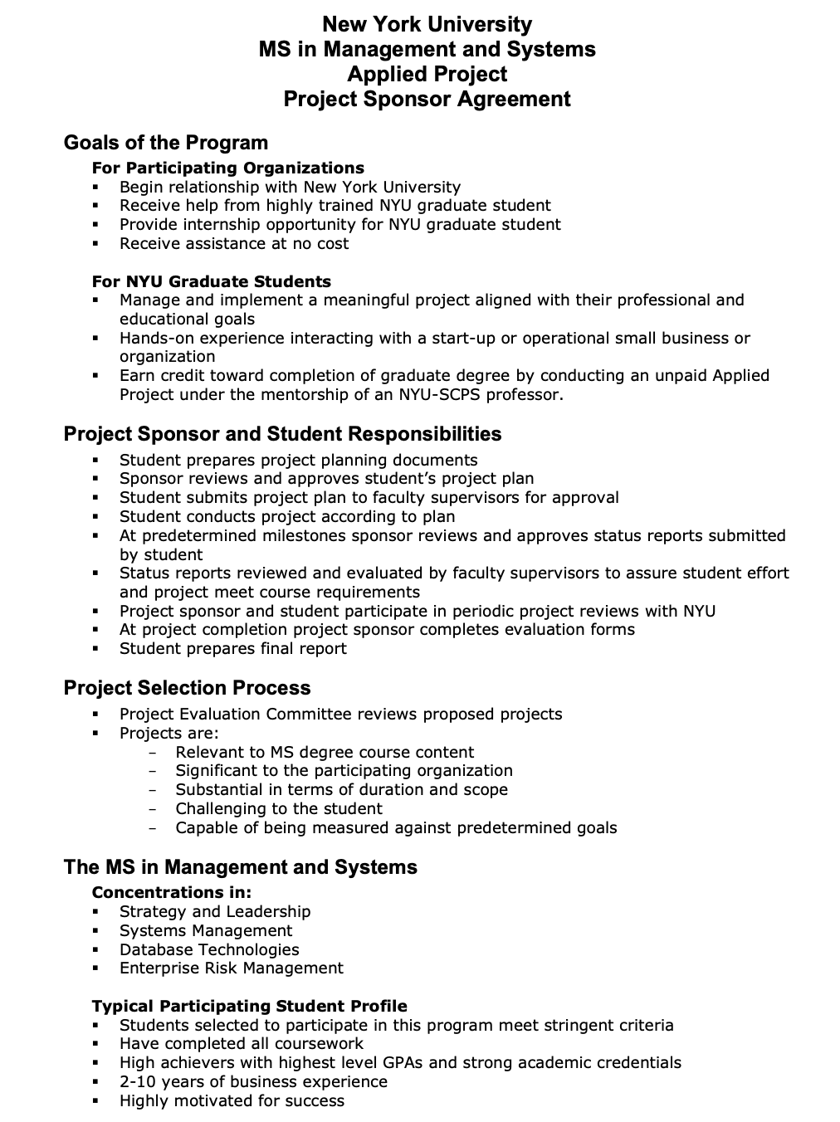

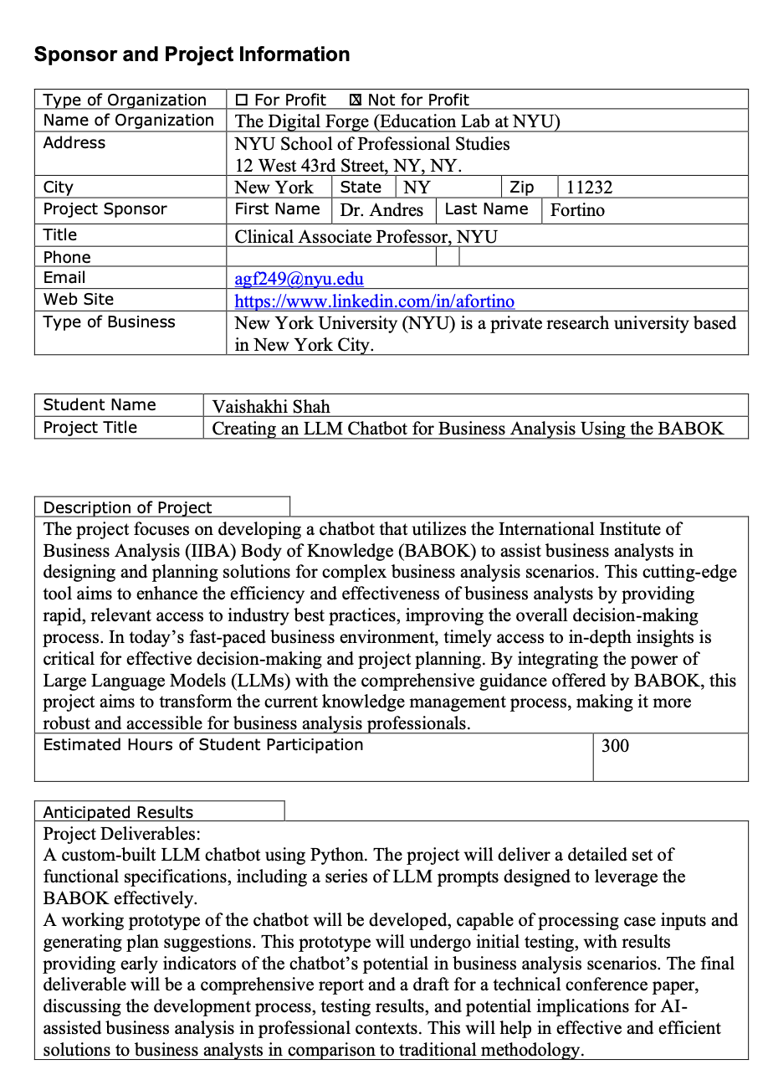

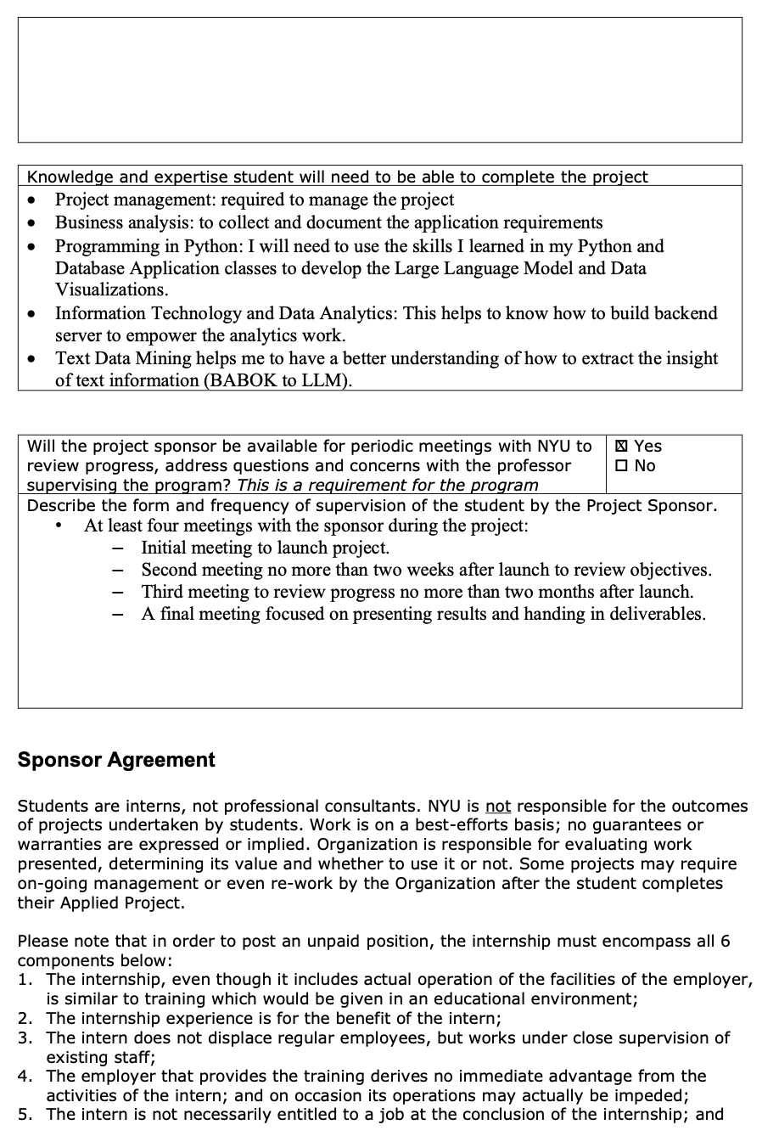

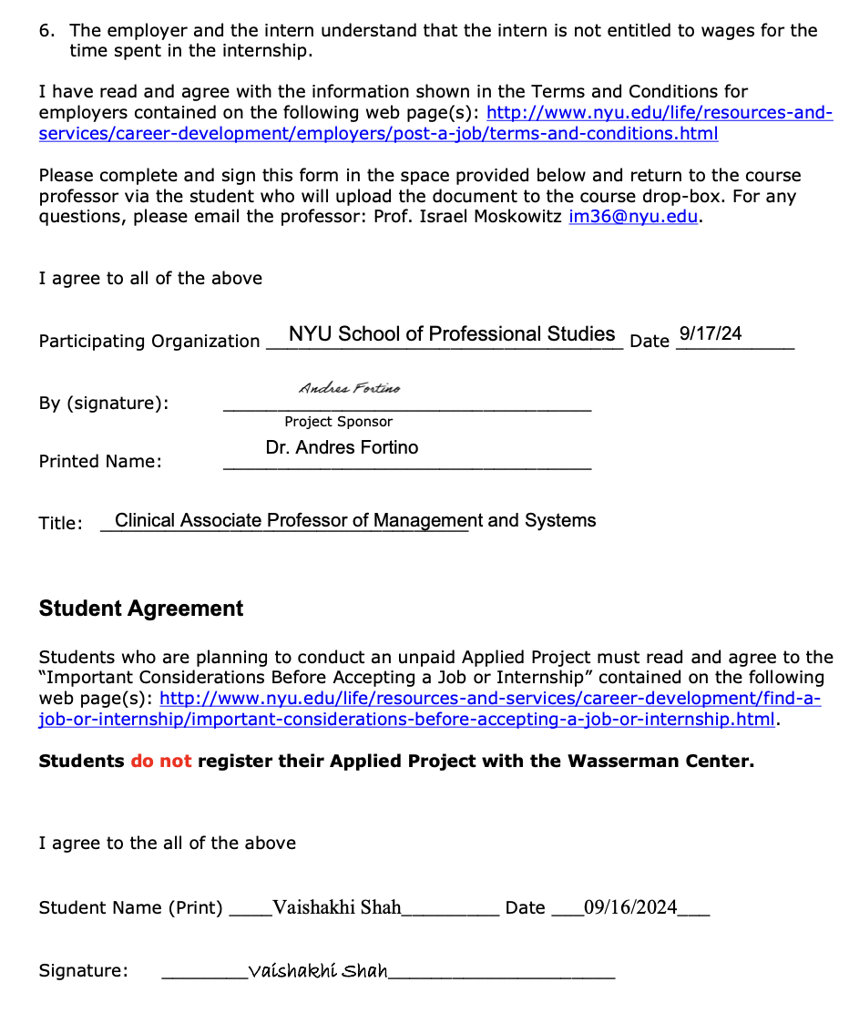

# Appendix C - Project Charter

Project Manager: Vaishakhi Shah

Sponsor: Dr. Andres Fortino

Prepared by: Vaishakhi Shah

Name and Location of Client Organization: The Digital Forge (Education Lab at NYU), NYU School of Professional Studies, 12 West 43rd Street, NY, NY.

1. **Project Goal**

The primary objective of this project is to create a chatbot that guides business analysts through the process of technology adoption and business analysis planning by utilizing the BABOK. Another objective of the project is to conduct initial trials applying the chatbot to various business analysis cases and compare its output to traditional methods. These trials will assess factors such as the relevance of the proposed solutions and time efficiency to determine the chatbot's overall effectiveness in real-world business analysis scenarios.

Business analysts face challenges in efficiently accessing and applying the comprehensive insights contained in the International Institute of Business Analysis (IIBA) Body of Knowledge (BABOK) when designing and planning solutions for complex business analysis cases. Traditional methods of consulting industry knowledge bases can be time-consuming and may not always provide contextually relevant advice in a timely manner. There is a need for a more efficient and effective way to leverage the BABOK's best practices in real-time business analysis scenarios, particularly in the rapidly evolving landscape of technology adoption and project planning.

1. **Problem/Opportunity Definition**

* Business analysts face challenges in efficiently accessing and applying the comprehensive insights contained in the International Institute of Business Analysis (IIBA) Body of Knowledge (BABOK) when designing and planning solutions for complex business analysis cases.
* Traditional methods of consulting industry knowledge bases can be time-consuming and may not always provide contextually relevant advice in a timely manner.
* There is a need for a more efficient and effective way to leverage the BABOK's best practices in real-time business analysis scenarios, particularly in the rapidly evolving landscape of technology adoption and project planning.

1. **Proposed Project Description**

The project focuses on developing a chatbot that utilizes the International Institute of Business Analysis (IIBA) Body of Knowledge (BABOK) to assist business analysts in designing and planning solutions for complex business analysis scenarios. This cutting-edge tool aims to enhance the efficiency and effectiveness of business analysts by providing rapid, relevant access to industry best practices, improving the overall decision-making process. In today’s fast-paced business environment, timely access to in-depth insights is critical for effective decision-making and project planning. By integrating the power of Large Language Models (LLMs) with the comprehensive guidance offered by BABOK, this project aims to transform the current knowledge management process, making it more robust and accessible for business analysis professionals.

1. **Project Sponsor**

Name and Title: Dr. Andres Fortino, Clinical Associate Professor, NYU, The Client. (https://www.linkedin.com/in/afortino)

Role within the organization: Teaches as Clinical Associate Professor at NYU.

Role on the project: Serves as the subject matter expert for the relevant project processes (Creating an LLM Chatbot for Business Analysis Using the BABOK). Approves project deliverables.

1. **Objectives**

* Objective #1: Deliver a functional requirement specification document and confirm the expected function with the client.
  + Measurement: The final version is due by 17th September 2024.
* Objective #2: Provide the technical design document including Data sources, Machine learning model, and testing methodology.
  + Measurement: The design document final version is due by 8th October 2024.
* Objective #3: Design and Develop the LLM Chatbot using BABOK guide.
  + Measurement: The design and development of Chatbot is due by 22nd October 2024.
* Objective #4: Trial Testing for the Harvard test case scenarios provided by the client.
  + Measurement: The chatbot is ready for testing due by 5th November 2024.
* Objective #5: Deploy and Validate the LLM Chatbot.
  + Measurement: The deployment and validation are due by 3rd December 2024.

1. **Project Selection & Ranking Criteria**

Project benefit category:

|  |  |
| --- | --- |
|  | Compliance/Regulatory |
| X | Efficiency/Cost reduction |
|  | Revenue increase |

Portfolio fit and interdependencies:

The increase in efficiency and productivity is realized by a.) Replacing the traditional system by Chatbot automation: This will help in effective and efficient solutions to business analysts in comparison to traditional methodology. b) by eliminating human errors and practicing standardized methodology to improve decision making process by saving time in learning and trainings.

Project urgency:

The delivery of the complete system will enable business analysts o to achieve significant time saving and increase efficiency in taking business decisions. However, this project has a limited, lower urgency, as it only delivers a POC for a functional subset of the functionality. The project can only be built as Proof of concept (POC) and require feature enhancements to expand its scope and area of expertise.

1. **Cost/Benefit Analysis**

**N.B: The project delivers a POC. The tangible benefits are only realized upon the completion and deployment of the complete system.**

Tangible Benefits

|  |  |  |
| --- | --- | --- |
| **Benefits** | **Value & Probability** | **Assumptions Driving Value** |
| Faster Access to Business Analysis Best Practices | Medium value, high probability | Assumes that the chatbot will enable business analysts to quickly access BABOK principles without manual reference. |
| Improved Efficiency in Business Analysis Tasks | High value, medium probability | Assumes that automating guidance using BABOK will reduce the time taken to make decisions or perform stakeholder analysis. |
| Reduction in Time Spent on Training Analysts | Medium value, medium probability | Assumes that the chatbot will reduce the need for lengthy training sessions, as analysts can consult it directly for answers. |

Intangible Benefits

|  |  |  |
| --- | --- | --- |
| **Benefits** | **Value & Probability** | **Assumptions Driving Value** |
| Increased Analyst Satisfaction | High value, High probability | Assumes that having an easily accessible chatbot with expert guidance will enhance job satisfaction and performance. |
| Improved Decision-Making Quality | High value, medium probability | Assumes that the chatbot's BABOK-based advice will enhance the quality of business analysis outcomes. |
| |  | | --- | | Reduced Human Error in Business Analysis |  |  | | --- | |  | | Medium value, High probability | Assumes that fewer errors will occur as analysts will rely on standardized BABOK advice instead of ad-hoc decisions. |

Cost Categories Amount

Internal Labor hours: Consultant, 300 hours @ $30 / hour; Estimated $9,000

External costs: N/A

Labor (consultants, contract labor): N/A

Equipment, hardware, or software: N/A

List other costs such as travel & training: N/A

Financial Return: N/A (as this project delivers a Proof of Concept, benefits realized only upon full deployment)

1. **Assumptions**
2. Resource(s) will be available to provide input on business processes, user testing and requirements.

2. Timely Access to Infrastructure and Tools and Consistent Access to Testing and Case Study Data.

3. The Project Sponsor will have availability to review and sign off project artifacts and participate to scheduled project meetings.

1. **Scope**

Quality

Scope will be reviewed and approved by the project sponsor.

Each deliverable will be tested to ensure that it meets the specifications outlined in the requirements.

Time

The project will start on Sept 3rd, 2024, and final version will be delivered on Dec 10th, 2024. I expect 20 hours per week on this project. Approximately 280 hours in total.

Resource Allocation

All the required equipment for programming is owned by the project manager.

Out of scope activities

The project can only be built as Proof of concept (POC), not the whole full fledge deployment and requires feature enhancements to expand its scope and area of expertise.

Constraints

1. Limited test case scenarios: The time limits the scope of the project by allowing limited testing of use case scenarios.

2. The project is bound by the timeline of a Semester in a university setting and thus the time to develop the tool is very limited.

3. This project delivers a POC; as such, the code is not production-quality

1. **Risks and Mitigation Strategies**

|  |  |  |  |  |
| --- | --- | --- | --- | --- |
| No. | Risk Description | Impact  (High/Medium/Low) | Likelihood  (High/Medium/Low) | Mitigation strategy |
| 1 | Data Quality Issues in the BABOK Text | High | Medium | - Test data extraction using various PDF parsing tools (e.g., pdfplumber, PyPDF2).  - Manually validate the extracted text to ensure accuracy and completeness. |
| 2 | Inaccurate or Incomplete Responses from Chatbot | High | High | - Implement regular testing with sample queries based on BABOK principles.  - Fine-tune or retrain the model if inaccuracies occur frequently. |
| 3 | Complexity of BABOK Content (Context Understanding) | High | Medium | - Use targeted training for specific BABOK topics and prioritize key business analysis questions.  - Provide additional context and examples during chatbot development and testing. |
| 4 | Delayed Milestones due to Integration Issues | Medium | Medium | - Clearly define integration points and set deadlines for each phase of the project (data extraction, LLM).  - Regularly monitor integration status through weekly team syncs and preempt potential bottlenecks. |
| 5 | Technical Bugs and Errors in Implementation | Medium | Medium | - Use agile development practices with frequent testing and debugging.  - Prepare a contingency plan for extended testing and debugging phases. |

Apart from the above technical risks, the time is limited to deliver the Chatbot and it’s for the 1st time I am implementing so, it is a learning curve.

1. **Communications Plan**

1. Frequency: Weekly

2. Method: ZOOM meetings

3. Content: Upload the weekly status reports on shared drive, which includes past week’s accomplishments, next week’s tasks, risks, issues, and project milestones (actual vs. planned time)

1. **Schedule Overview**

Project Start Date: Sept 3rd, 2024.

Estimated Project Completion Date: Dec 10th, 2024.

Major Milestones

1. Project Planning: 09/24/2024
2. Functional Requirements completed: 10/08/2024
3. LLM Chatbot Development: 10/22/2024
4. Chatbot Trial Testing: 11/05/2024
5. Chatbot Deployment and Validation: 12/03/2024
6. Final Deliverables of report and presentation: 12/10/2024

External Milestones Affecting the Project: Project needs to be completed by the end of the Fall semester (Dec 10th, 2024)

1. **Impact of Late Delivery**

This project is the first phase of a larger initiative, which will deliver the overall creation of an LLM Chatbot for Business Analysis Using the BABOK. Delays in delivering this phase may delay the delivery of the completed Chatbot.

1. **Resources Required**

Personnel:

|  |  |  |  |
| --- | --- | --- | --- |
| **Role** | **Responsibilities** | **Duration of work** | **Qualifications needed** |
| Myself | Project Management; Consultant and Developer, Requirements Collection and Documentation; Product Management, Design and Coding, Test and Deploy the results of the technology trial. | 300 hours | Solid project management and business analysis skills  Moderate logical and technical and coding skills Python |
| Dr. Andres Fortino | Project Sponsor | 20-30 hours | Business expertise in the relevant project processes |
| Dan Stone | Advisor | 10 hours | Project management; high-level solution architecture skills; process and data analysis skills |

Data:  
The data from business platforms (test case scenarios) as an input of data sources for my machine learning model (LLM). To train and test this model, I can get the test case scenarios of Harvard case studies given by my guide ahead of time.

Facilities, Software, Hardware and other Resources:  
Laptop, Python Software, BABOK Guidebook, ChatGPT

Procedures/ Methodology:

Waterfall

1. **Project Plan, Gantt**

CAPSTONEPROJECT_GANTTCHART_VaishakhiShah-N17270584.mpp

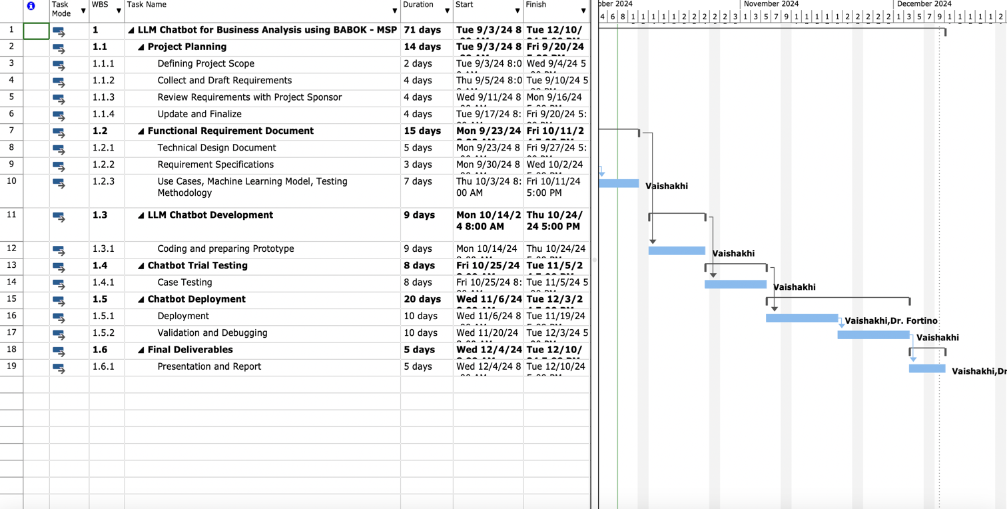

[Excel_Project Gantt Chart_WBS](https://docs.google.com/spreadsheets/d/1oV5XnozjAJcO9JeNLjZ5jlnpTDZYNdNjFsUPO5m9KzA/edit?gid=0#gid=0)

1. **Project Evaluation** (How the project will be evaluated)
2. Project schedule

The actual progress will be measured against the Gantt chart/schedule, which details the timeline for the project work and the dates of each deliverable. The progress will be shared with the project sponsor and the NYU advisor, via the “Project Weekly Status Report” described below.

1. Project weekly status report and dashboard

The weekly report will cover the tasks completed, upcoming tasks, risks, issues, and the up-to-date project schedule. It will be developed using Microsoft Word, Excel or PowerPoint and made available to the Project Sponsor and Advisor.

1. Project communication plan, issues log, risk register

Project risks and issues are tracked and managed using the risk register (risks) and the issue log (issues). Their status will be included in the “Project weekly status report and dashboard”.

1. Project status reports

Various timely project status reports will be submitted.

Publishing Schedule:

* Weekly Status Reports: Every Tuesday to the project sponsor and advisor.
* Milestone Reports: As milestones are achieved to the advisor and project sponsor.
* Monthly Progress Reports: Last working day of each month.
* Risk and Issue Reports: Every two weeks or as needed.
* Final Project Report: At project completion.

# Appendix D - Project Plan

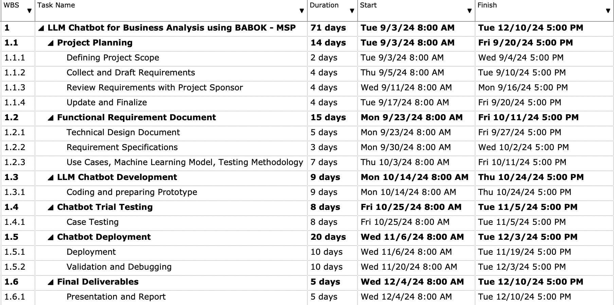

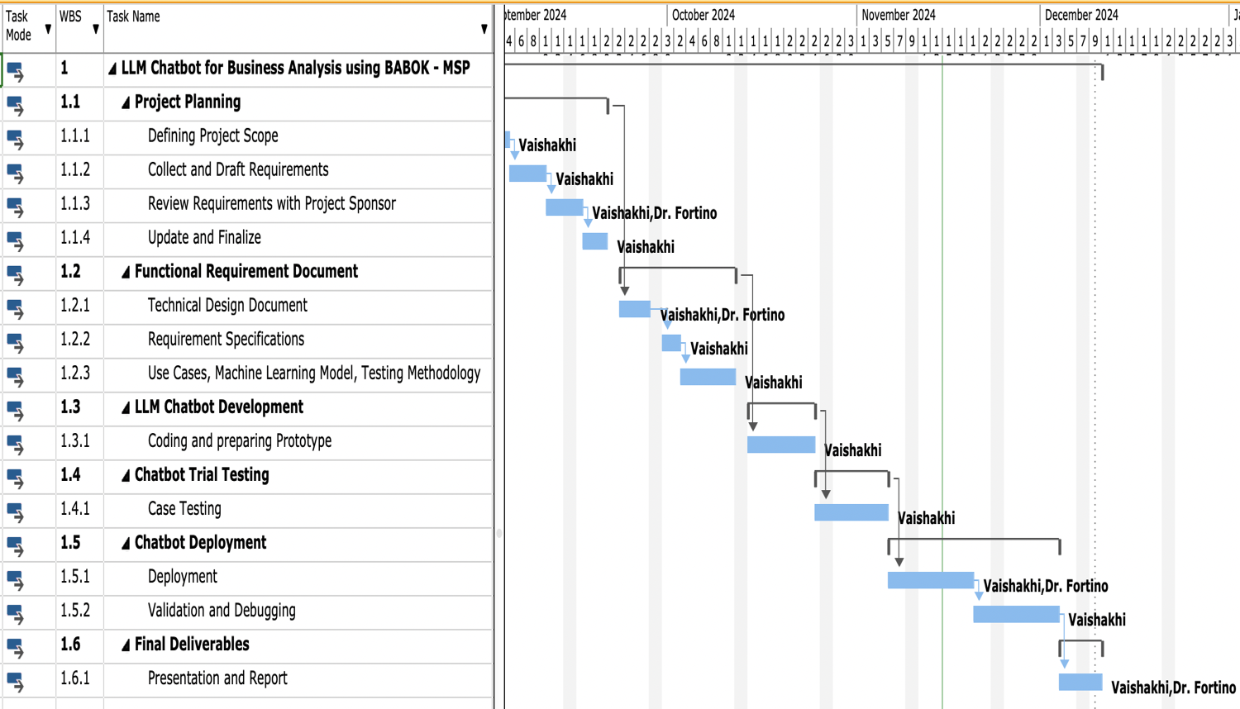

# Appendix E - Status Report

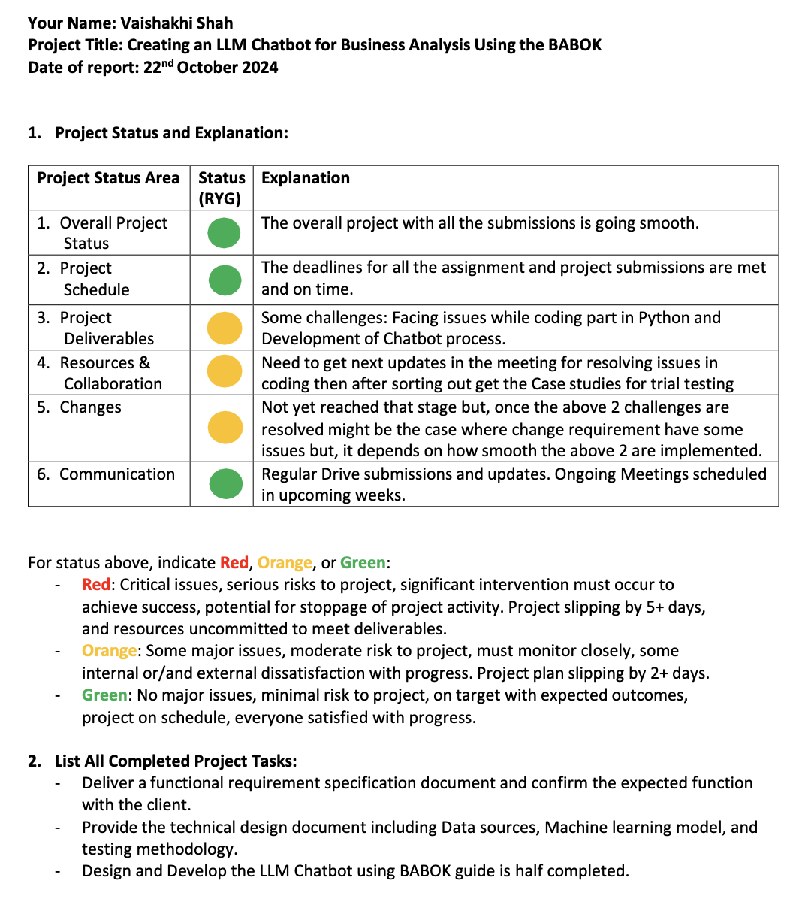

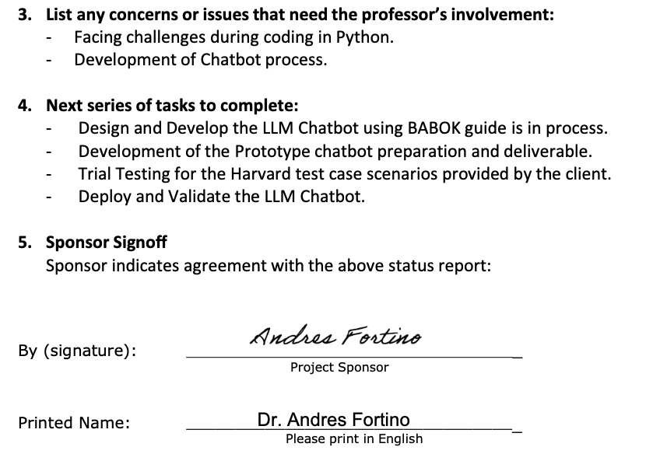

# Appendix F - Annotated Bibliography

1. Chen, Y., Jensen, S., Albert, L. J., Gupta, S., & Lee, T. (2023). Artificial intelligence (AI) student assistants in the classroom: Designing chatbots to support student success. *Information Systems Frontiers*, *25*(1), 161-182. <https://doi.org/10.1007/s10796-022-10291-4>

*In higher education, low teacher-student ratios can make it difficult for students to receive immediate and interactive help. Chatbots, increasingly used in various scenarios such as customer service, work productivity, and healthcare, might be one way of helping instructors better meet student needs. However, few empirical studies in the field of Information Systems (IS) have investigated pedagogical chatbot efficacy in higher education and fewer still discuss their potential challenges and drawbacks. In this research we address this gap in the IS literature by exploring the opportunities, challenges, efficacy, and ethical concerns of using chatbots as pedagogical tools in business education. In this two study project, we conducted a chatbot-guided interview with 215 undergraduate students to understand student attitudes regarding the potential benefits and challenges of using chatbots as intelligent student assistants. Our findings revealed the potential for chatbots to help students learn basic content in a responsive, interactive, and confidential way. Findings also provided insights into student learning needs which we then used to design and develop a new, experimental chatbot assistant to teach basic AI concepts to 195 students. Results of this second study suggest chatbots can be engaging and responsive conversational learning tools for teaching basic concepts and for providing educational resources. Herein, we provide the results of both studies and discuss possible promising opportunities and ethical implications of using chatbots to support inclusive learning.*

**This study explores the design and efficacy of AI-driven chatbots as pedagogical tools, highlighting their ability to deliver interactive and confidential learning support while addressing challenges and ethical concerns. Relevant to my project, I have used Juji Studio that provides insights into designing educational chatbots helping and facilitating with the learning and demonstrating the potential of chatbots to support complex subjects like business analysis by adapting to learner needs, a key component in my BABOK-aligned chatbot development.**

1. Chuma, E. L., & De Oliveira, G. G. (2023). Generative AI for business decision-making: A case of ChatGPT. *Management Science and Business Decisions*, *3*(1), 5-11. <https://doi.org/10.52812/msbd.63>

*ChatGPT (Generative Pretrained Transformer) is a chatbot using artificial intelligence (AI) launched by OpenAI, which is an AI research and deployment company. The ChatGPT has taken the technology world by storm. The ChatGPT is a trained AI model that can chat almost like a human. The dialog format allows the ChatGPT to answer follow-up questions, admit mistakes, challenge incorrect premises, and reject inappropriate requests. The ChatGPT can be utilized for compiling research, drafting marketing content, brainstorming ideas, delivering aftercare services, increasing customer engagement, and many others. The ChatGPT can provide enormous opportunities for companies leveraging this breakthrough technology strategically. Thus, we evaluate ChatGPT as a tool in common business decision-making cases in the current study. For example, the ChatGPT was asked about the impacts of a hypothetical merging of two supermarket chains in Sweden. In another example, the ChatGPT was asked about recommendations for investment in a Brazilian oil company. Finally, it was asked about the factors that influence online shopping behavior. The results are significant and demonstrate the tremendous potential of the ChatGPT in revolutionizing the corporate world.*

**This article explores the use of ChatGPT in business decision-making, showcasing its ability to analyze hypothetical cases for business recommendations. The findings suggest that ChatGPT can significantly enhance decision-making processes by providing informed and dynamic insights, aligning well with my capstone focus on generative AI in business analysis.**

1. Dam, S. K., Hong, C. S., Qiao, Y., & Zhang, C. (2024). A complete survey on llm-based ai chatbots. *arXiv preprint arXiv:2406.16937*. <https://doi.org/10.48550/arXiv.2406.16937>

*The past few decades have witnessed an upsurge in data, forming the foundation for data-hungry, learning-based AI technology. Conversational agents, often referred to as AI chatbots, rely heavily on such data to train large language models (LLMs) and generate new content (knowledge) in response to user prompts. With the advent of OpenAI's ChatGPT, LLM-based chatbots have set new standards in the AI community. This paper presents a complete survey of the evolution and deployment of LLM-based chatbots in various sectors. We first summarize the development of foundational chatbots, followed by the evolution of LLMs, and then provide an overview of LLM-based chatbots currently in use and those in the development phase. Recognizing AI chatbots as tools for generating new knowledge, we explore their diverse applications across various industries. We then discuss the open challenges, considering how the data used to train the LLMs and the misuse of the generated knowledge can cause several issues. Finally, we explore the future outlook to augment their efficiency and reliability in numerous applications. By addressing key milestones and the present-day context of LLM-based chatbots, our survey invites readers to delve deeper into this realm, reflecting on how their next generation will reshape conversational AI.*

**This paper comprehensively examines the evolution and deployment of LLM-based AI chatbots, emphasizing their knowledge generation from extensive datasets and the advancements in models like GPT. It also discusses challenges such as data misuse and knowledge inaccuracies, which are critical for my capstone project.**

1. Ferreira, D., Portela, F., & Santos, M. F. (2021). A step towards the use of chatbots to support the enterprise decision-making processes. In *Trends and Applications in Information Systems and Technologies: Volume 4 9* (pp. 308-317). Springer International Publishing. <https://doi.org/10.1007/978-3-030-72654-6_30>

*Chatbots are informatics applications that use Artificial Intelligence and natural language interfaces to simulate interactions with the end-user, providing a pleasant user experience. Generally, chatbots are related to customer service, trying either to answer the frequently asked questions that do not need direct human interaction or to generate leads to the after-client follow-up and contact. Chatbots represent a potential change in the way that people interact with information and online services. This article addresses the creation of a chatbot capable of generating insights for a manager on the decision-making process and the advantages that it represents. In order to create the referred chatbot, it is crucial to deal with multiple API’s interconnected, external services, and numerous databases from the organizations, always focused on the improvement of the business process like the time optimization and the quality of the information retrieved, and the user experience related to them. Further system analysis shows a time saving of approximately 60% compared to the traditional way to access the information.*

**In this article,** **Ferreira et al. (2021) discuss the development of AI-driven chatbots to enhance enterprise decision-making by optimizing workflows and providing quality insights through data analysis. This research aligns with my capstone project by illustrating how chatbots can improve decision-making efficiency and save time compared to traditional methods.**

1. Goswami, I., & Gupta, D. (2024). Building and AI Chatbot using LLM.

*In our digital world, where communication is key, the emergence of AI-powered chatbots has revolutionized the way we interact with technology. This project delves into the development of an AI chatbot utilizing Large Language Models (LLM), a cutting-edge technology in the field of natural language processing. The journey begins with a comprehensive exploration of existing chatbot frameworks and technologies, analysing their strengths and weaknesses. Through meticulous research, we identified LLM as the most promising candidate due to its ability to understand and generate human-like text, enabling more meaningful and engaging conversations. The LLM was employed for its ability to process long range dependencies, enabling the chatbot to comprehend context in a more comprehensive manner. The report discusses the methodology employed, including data preprocessing, model training, the transformer architecture and validation using the test cases along with the conclusion and the work we wish to do in the upcoming months. Additionally, it details the challenges encountered and the strategies employed to counter them and enhance the chatbot’s performance. The final AI chatbot demonstrates impressive capabilities in understanding and generating human-like responses across a diverse range of topics. Its ability to engage users in meaningful conversations showcases the potential of LLM technology in enhancing human- computer interaction. Overall, this project contributes to the evolving field of AI-driven conversational agents and highlights the potential of utilizing LLMs in building sophisticated chatbot systems.*

**In this research paper, Goswami and Gupta's research focuses on developing an AI chatbot using Large Language Models (LLM), emphasizing improvements in human-computer interaction through effective data preprocessing and model training. This work closely aligns with my capstone, demonstrating practical applications of LLMs in creating advanced conversation with Bot for business analysis using Python language which I am using for my project.**

1. Kumar, V., Srivastava, P., Dwivedi, A., Budhiraja, I., Ghosh, D., Goyal, V., & Arora, R. (2023, December). Large-Language-Models (LLM)-Based AI Chatbots: Architecture, In-Depth Analysis and Their Performance Evaluation. In *International Conference on Recent Trends in Image Processing and Pattern Recognition* (pp. 237-249). Cham: Springer Nature Switzerland. <https://doi.org/10.1007/978-3-031-53085-2_20>

*This scholarly article conducts a comparative evaluation of prominent large-scale language models, specifically encompassing Google’s BARD, ChatGPT 3.5, and ChatGPT 4. It offers a comprehensive dissection of each model, elucidating aspects such as architectural structure, utilized training data, and proficiency in natural language processing. The paper also undertakes a systematic assessment of these models in executing diverse tasks like text generation, text completion, and question-answering, paralleling their precision, processing speed, and efficiency. The concluding part of the article explores the prospective application domains of these language models, including but not limited to customer service, education, and healthcare sectors, while proffering suggestions for future research trajectories and technological enhancements. In summary, the study furnishes critical insights into the current status of large-scale language models, shedding light on their potential to augment human-computer interaction and drive forward advancements in the realm of natural language processing technology.*

**This study evaluates prominent LLM-based AI chatbots, including ChatGPT 3.5, ChatGPT 4, and Google’s BARD, analyzing their architecture, training data, and performance in tasks like text generation and question-answering. This research is relevant to my capstone as it highlights practical applications of LLMs in enhancing human-computer interaction for my business analysis chatbot using the BABOK.**

1. Ngo Tran, G. T., Le Dinh, T., & Pham-Nguyen, C. (2024, August). BABot: A Framework for the LLM-Based Chatbot Supporting Business Analytics in e-Commerce. In *International Conference on Computational Collective Intelligence* (pp. 185-198). Cham: Springer Nature Switzerland. <https://doi.org/10.1007/978-3-031-70816-9_15>

*In recent times, there has been a surge in the use of chatbots built from Large Language Models (LLMs). By leveraging text generation capabilities instead of being confined to a predefined script, LLM-based chatbots have gained popularity and exerted a significant influence on the development of chatbot technology. This paper presents a framework for a chatbot that conducts conversations about business analytics in e-commerce. The framework is based on GPT-4, an LLM model capable of generating responses to assist users in deriving business insights from data and making informed decisions. The proposed framework is constructed using a process that combines several techniques for data aggregation, data visualization, and insight generation incorporating with various prompt templates. It is implemented by integrating into Trivi, a customer-intelligent platform for SMEs. An experiment was carried out to evaluate its performance, using different datasets, revealing that this approach is slightly better than previous works.*

**The paper introduces a framework for an LLM-based chatbot utilizing GPT-4 to enhance business analytics in e-commerce by generating meaningful responses and extracting valuable data insights. This research aligns with my capstone by demonstrating innovative applications of LLMs in delivering actionable business intelligence.**

# Appendix G - Annotated Testing Procedure

